What is TypeScript

Thursday, November 30, 2023

11:52 AM

Add new Features + Advantages to JS

Browser does NOT execute TypeScript

A Superset to JS, offering:

Types checking for:

number

string

object

Nested objects

Arrays

Tuples ['Hi', 123]

Enums

Any

Union => type ComplexTypeAlias = { name: string; age: number; } | string;

Literals

====

TS => Compiled to JS

Featrues are compiled from .ts to .js through 'tsc ./app.ts' as "workarounds", possible errors are thrown

**Extra errors catching & alerts** before actually compiling into a bundle

JS:

const add = (num1, num2) => {

return num1 + num2;

}

// Unwanted Behaviour at Runtime

console.log(add('2','3'));

Mitigation Strategies:

Add if check to add function

Validate & sanitize user input

Dev can still write invalid code, yet TS helps validating code

TypeScript:

index.html:

<!DOCTYPE html>

<html lang="en">

  <head>

    <meta charset="UTF-8" />

    <meta name="viewport" content="width=device-width, initial-scale=1.0" />

    <meta http-equiv="X-UA-Compatible" content="ie=edge" />

    <title>Understanding TypeScript</title>

    <script src="js-only.js" defer></script>

  </head>

  <body>

    <input type="number" id="num1" placeholder="Number 1" />

    <input type="number" id="num2" placeholder="Number 2" />

    <button>Add!</button>

  </body>

</html>

js-only.js:

const button = document.querySelector("button");

const input1 = document.getElementById("num1");

const input2 = document.getElementById("num2");

function add(num1, num2) {

  return num1 + num2;

}

button.addEventListener("click", function() {

  console.log(add(input1.value, input2.value));

  console.log(`${typeof document.getElementById("num1").value}`);

});

// document.getElementById("num1").value = always a TEXT

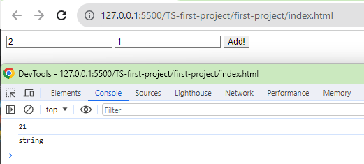

***

add(2, 1) should be 3 (typeof: number)

Instead of '2'+'1' => '3' (typeof: text)

***

Installing TypeScript

Thursday, November 30, 2023

11:57 AM

**// Installation**

**npm install -g typescript;**

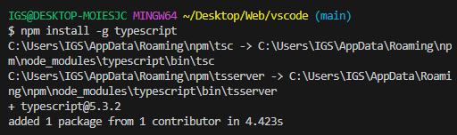

// To compile a .ts => .js

tsc ./test.js

previously

js-only.js:

const button = document.querySelector("button");

const input1 = document.getElementById("num1");

const input2 = document.getElementById("num2");

function add(num1, num2) {

  return num1 + num2;

}

button.addEventListener("click", function() {

  console.log(add(input1.value, input2.value));

  console.log(`${typeof document.getElementById("num1").value}`);

});

// document.getElementById("num1").value = always a TEXT

using-ts.ts:

// ! = This will always find an HTMLButtonElement & NOT yield NULL

const button = document.querySelector("button")! as HTMLButtonElement;

// ! = This will always find an element & NOT yield NULL

const input1 = document.getElementById("num1")! as HTMLInputElement;

// ! = This will always find an element & NOT yield NULL

const input2 = document.getElementById("num2")! as HTMLInputElement;

const add = (num1: number, num2: number) => {

  return num1 + num2;

}

button.addEventListener("click", function() {

  // Adding +input1.value => Make sure it's a number !string

  console.log(add(+input1.value, +input2.value));

  //console.log(`typeof input1.value: ${typeof document.getElementById("num1").value}`);

});

// document.getElementById("num1").value = always a TEXT

==== Compile .ts to .js:

tsc ./using-ts.js;

Will still get a .js file with errors

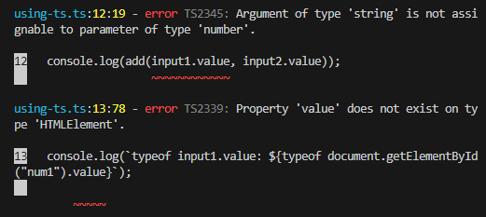

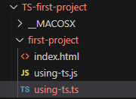

Overview

Thursday, November 30, 2023

12:21 PM

TypeScript adds....

Types

Next-gen JS Features (compiled down for older Browsers)

[e.g. babel]

Non-JS Features like **interfaces** or **Generics**

Meta-Programming Features like **Decorators**

Rich **Configuration** Options

Modern Tooling that helps even in non-TypeScript Projects

Outline

Thursday, November 30, 2023

12:24 PM

1. Getting Started

2. TypeScript basics

3. Compiler & Configuration Deep Dive

4. Next-gen JS code (ES6+)

5. Classes & Interfaces

6. Advanced Types & TypeScript Features

7. Generics

8. Decorators

9. Practice (all TypeScript features learnt in action)

10. Namespaces & Modules

11. Webpack & TypeScript

12. Third-Party Libraries & TypeScript

13. Integrating TypeScript into React, Node, Express

lite-server

Thursday, November 30, 2023

1:18 PM

Package.json:

{

  "name": "understanding-ts",

  "version": "1.0.0",

  "main": "app.js",

  "scripts": {

    "test": "echo \"Error: no test specified\" && exit 1",

    "start": "lite-server"

  },

  "author": "Maximilian Schwarzmüller",

  "license": "ISC",

  "devDependencies": {

    "lite-server": "^2.5.4"

  },

  "keywords": [],

  "description": ""

}

npm init -y;

Types (number, string)

Thursday, November 30, 2023

1:23 PM

number = int, bigint, floats

string = text ('Hi', "Hi", `Hi`)

boolean = true, false

==== **Types assignment**

app.ts:

// Using Type inference

const add = (n1: number, n2: number, showResult: boolean, phrase: string) => {

    // in the past...

    // if (typeof n1 !== 'number' || typeof n2 !== 'number') {

    //     throw new Error('Incorrect input!');

    // }

    // Only numbers are involved

    let result = n1 + n2;

    if (showResult) {

        console.log(phrase + result);

    } else {

        return n1 + n2;

    }

}

const number1 = 5;

const number2 = 2.8;

const printResult = true;

const resultPhrase = 'Result is: ';

add(number1, number2, printResult, resultPhrase);

Type (object)

Thursday, November 30, 2023

1:54 PM

app.ts:

const person = {

    name: 'Max',

    age: 30

};

console.log(person.nickname);

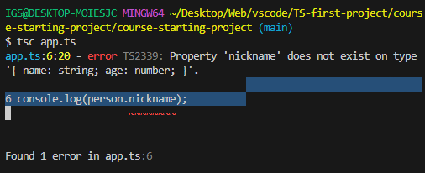

app.ts:

// Traditional js object

const person = {

name: 'Max',

age: 30

};

console.log(person.name);

// Adding **object types** to 'person'

const person: **{}** = {

name: 'Max',

age: 30

};

// Expanding the object type {}

const person: **{**

**name: string;**

**age: number;**

**}** = {

name: 'Max',

age: 30

};

console.log(person.name);

Types (Nested Objects)

Thursday, November 30, 2023

2:07 PM

// Let's say having a JS object

const product = {

id: 'abc1',

price: 12.99,

tags: **['great-offer', 'hot-and-new']**;

details: {

title: 'Red Carpet',

description: 'A great carpet - almost brand new!'

}

}

// Adding Nested **type** to 'product'

const product = {

id: string;

price: number;

tags: **string[]**;

details: {

title: **string**;

description: **string**;

}

} = {

id: 'abc1',

price: 12.99,

tags: ['great-offer', 'hot-and-new'];

details: {

title: **'Red Carpet'**,

description: **'A great carpet - almost brand new!'**

}

}

Types (Arrays)

Thursday, November 30, 2023

2:10 PM

// Flexible OR Strict

app.ts:

const person: {

    name: string;

    age: number;

    hobbies: string[];

} = {

    name: 'Max',

    age: 30,

    hobbies: ['Sports', 'Cooking'],

};

// Type for array of strings

let favActivities: string[];

// Will ERR if ! array

//favActivities = 'Sports';

favActivities = ['Sports', 'Cooking'];

//console.log(person.name);

// From JS

for (const hobby of person.hobbies) {

    console.log(hobby.toUpperCase());

    // will NOT get .map() because hobby !array

    //console.log(hobby.map());

}

Types (Tuple - not in JS)

Thursday, November 30, 2023

2:16 PM

Tuple [number, string];

Tuple [1, 'Hi'];

Added by TypeScript:

Fixed-length array

Tuple [1, 2]

Tuple ['Hi', 2]

app.ts:

const person: {

    name: string;

    age: number;

    hobbies: string[];

    role: **(string|number**)[]; //Tuple

} = {

    name: 'Max',

    age: 30,

    hobbies: ['Sports', 'Cooking'],

    role: [2, 'author'],

};

// Type for array of strings

let favActivities: string[];

// Will ERR if ! array

//favActivities = 'Sports';

favActivities = ['Sports', 'Cooking'];

//console.log(person.name);

// From JS

for (const hobby of person.hobbies) {

    console.log(hobby.toUpperCase());

    // will NOT get .map() because hobby !array

    //console.log(hobby.map());

}

const person: {

    name: string;

    age: number;

    hobbies: string[];

    //role: (string|number)[];

    role: [number, string]; //Tuple

} = {

    name: 'Max',

    age: 30,

    hobbies: ['Sports', 'Cooking'],

    role: [2, 'author'],

};

// Pushing an extra string to Tuple 'role'

person.role.push('admin');

// Switching an obj.key to another value

person.role[1] = 10; // This checks for Type of role[1] => string

Types (Enum - not in JS)

Thursday, November 30, 2023

2:39 PM

enum name { NEW, OLD }

Added by TypeScript:

Automatically enumerated global constant identifiers

app.ts:

enum Role {

ADMIN = 'ADMIN',

READ_ONLY = 100,

AUTHOR = 200

};

const person: {

name: string,

age: number,

hobbies: string[],

role: string

} = {

    name: 'Max',

    age: 30,

    hobbies: ['Sports', 'Cooking'],

    role: Role.ADMIN,

};

if (person.role === Role.ADMIN) {

    console.log(`person is admin`);

}

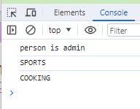

Types (Any *)

Thursday, November 30, 2023

3:02 PM

Any:

Strips off the advantages of using TypeScript

Ignore all Type limits

let favActivities: any[];

favActivities = ['Sports', 'Cooking'];

Types (Union |)

Thursday, November 30, 2023

3:08 PM

**Commonly used when multiple types of Data can be inputs of a function**

app.ts:

// 22. Union Types

// =========== Union ===================

const combine = (

    input1: number | string,

    input2: number | string

    ) => {

    let result: number | string;

    if (typeof input1 === 'number' && typeof input2 === 'number') {

        result = input1 + input2;

    } else {

        result = input1.toString() + input2.toString();

    }

    return result;

}

const combinedAges = combine(30, 26);

console.log(`combinedAges: ${combinedAges}`);

const combinedNames = combine('Max', 'Anna');

console.log(`combinedNames: ${combinedNames}`);

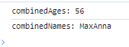

Types (Literals) & custom aliases

Friday, December 8, 2023

3:40 PM

// =========== Literals ===================

// Creating custom aliases

type Combinable = number | string;

type ConversionDescriptor = 'as-number' | 'as-text';

const combine = (

input1: Combinable,

input2: Combinable,

//resultConversion: string

// Limiting resultConversion types to a Union type

resultConversion: ConversionDescriptor

) => {

//let result: Combinable;

let result;

if (typeof input1 === 'number' && typeof input2 === 'number' || resultConversion === 'as-number') {

// Adding + in front of input1 to force type coersion to number

result = +input1 + +input2;

} else {

result = input1.toString() + input2.toString();

}

return result;

// if (resultConversion === 'as-number') {

// return parseFloat(result);

// } else {

// return result.toString();

// }

}

const combinedAges = combine(30, 26, 'as-number');

console.log(`combinedAges: ${combinedAges}`);

const combinedStringAges = combine('30', '26', 'as-number');

console.log(`combinedStringAges: ${combinedStringAges}`);

const combinedNames = combine('Max', 'Anna', 'as-text');

console.log(`combinedNames: ${combinedNames}`);

Type aliasing1

Thursday, January 11, 2024

5:49 PM

type-aliases.ts:

// 24. && 25.

// Type Aliases

type Combinable = number | string;

type ConversionDes = 'as-number' | 'as-text';

// =========== Union ===================

const combine = (

    // Union Type

    input1: Combinable,

    input2: Combinable,

    //resultConversion: string,

    // Literal Type

    resultConversion: ConversionDes

    ) => {

    let result: Combinable;

    if (

        typeof input1 === 'number' &&

        typeof input2 === 'number' ||

        resultConversion === 'as-number'

        ) {

        // Adding +var to ensure = number

        result = +input1 + +input2;

    } else {

        result = input1.toString() + input2.toString();

    }

    return result;

    // if (resultConversion === 'as-number') {

    //     return parseFloat(result);

    // } else {

    //     return result.toString();

    // }

}

const combinedAges = combine(30, 26, 'as-number');

console.log(`combinedAges: ${combinedAges}`);

const combinedStringAges = combine(30, 26, 'as-text');

console.log(`combinedStringAges: ${combinedStringAges}`);

const combinedNames = combine('Max', 'Anna', 'as-text');

console.log(`combinedNames: ${combinedNames}`);



Type aliasing2

Friday, December 8, 2023

3:56 PM

// Creating own custom type alias

type User = {

name: string;

age: number;

};

// Can also create complex type aliases e.g.

type Complex = { name: string; age: number; } | string | number;

const greet = (user: User) => {

console.log(`Hi, I am ${user.name}`);

};

const isOlder = (user: User, checkAge: number) => {

return checkAge > user.age;

}

// Rather than

// const gree = (user: {

// name: string;

// age: number;

// }) => {

// console.log(`Hi, I am ${user.name}`);

// }

// const isOlder = (user: { name: string; age: number; }, checkAge: number) => {

// return checkAge > user.age;

// }

=== Func return Types & void

Thursday, January 11, 2024

4:19 PM

Functions Types

Saturday, March 2, 2024

9:32 PM

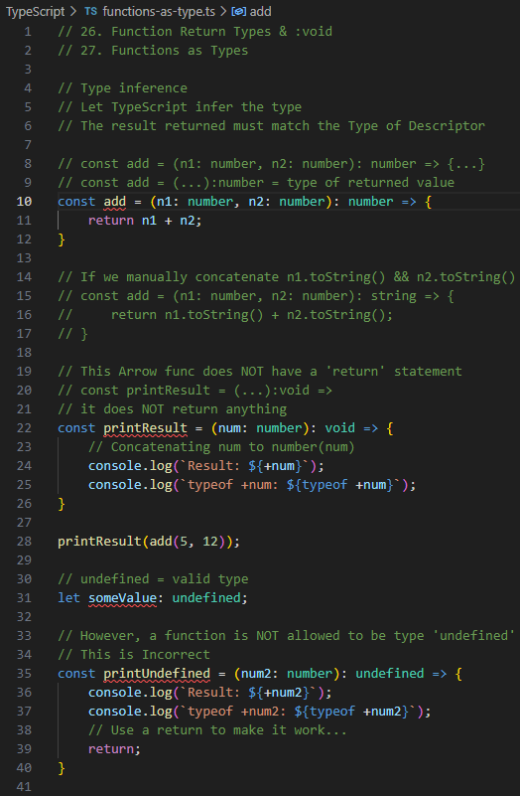

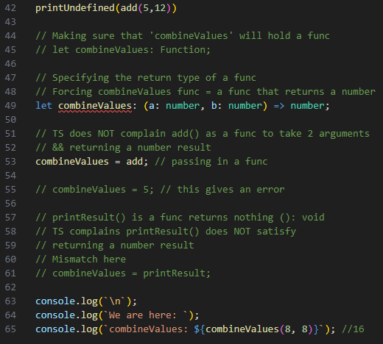

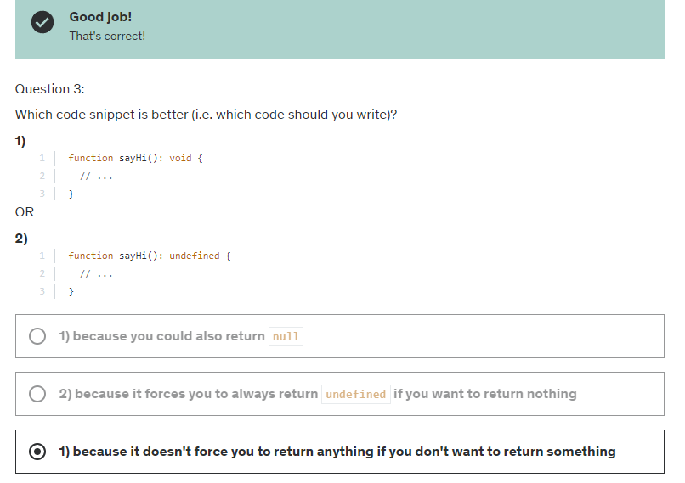

unknown type

Tuesday, March 12, 2024

2:37 PM

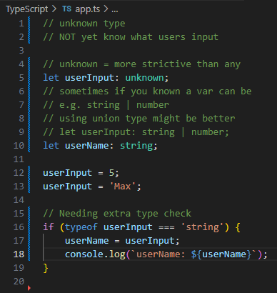

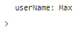

never type

Tuesday, March 12, 2024

3:44 PM

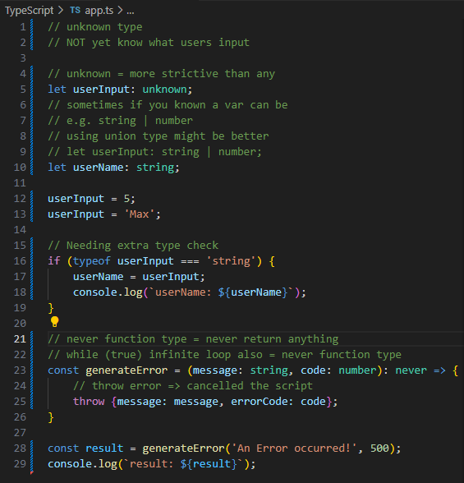

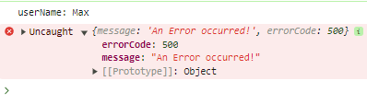

=== TSC (TypeScript Compiler)

Friday, March 15, 2024

10:45 AM

watch mode

Friday, March 15, 2024

10:48 AM

tsc app.ts -w;

// Compiling entire project or multiple files

tsc --init;

tsconfig.json comes up

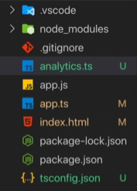

// Excluding a .ts from tsconfig.json

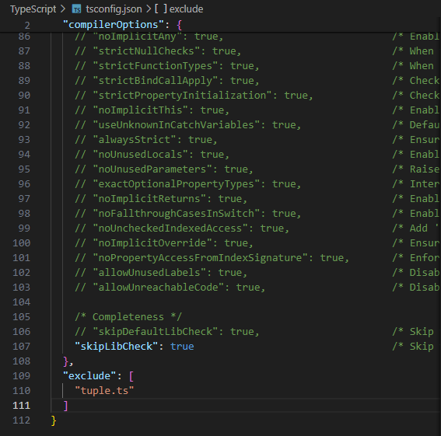

// ignoring any folders *.dev.ts files

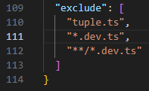

// If using "include" key

// need to include everything for "include" to work

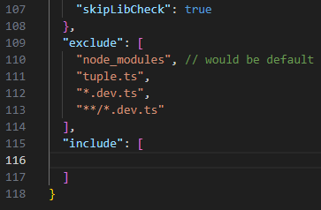

// CompilerOptions

"target": "es5",

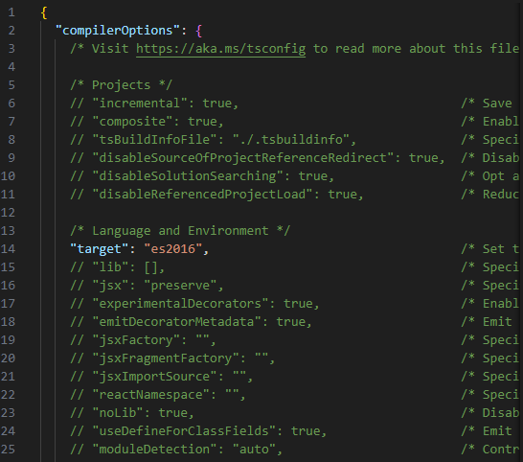

// "lib"

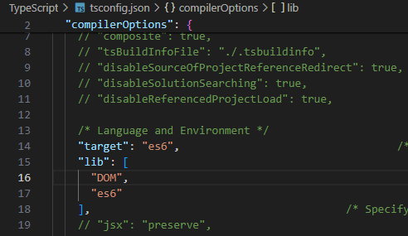

source maps

Friday, April 5, 2024

1:32 PM

// Sources of our live-server

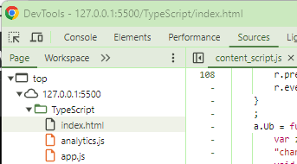

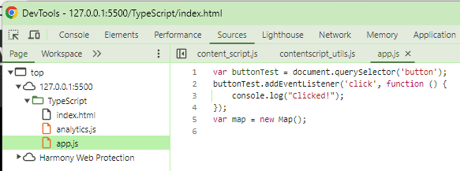

Uncommenting sourceMap in tsconfig.json

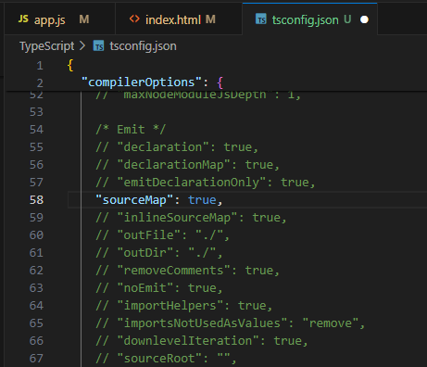

terminal:

tsc

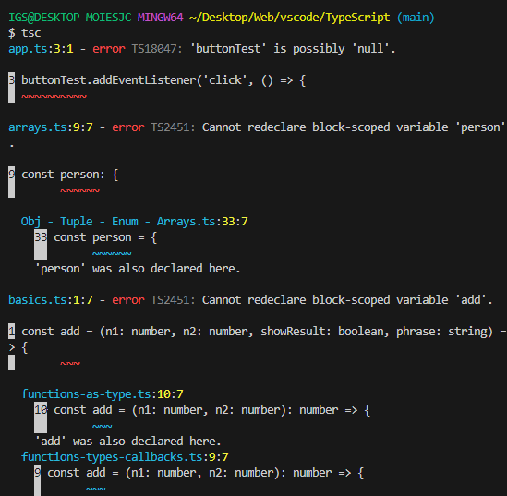

we'll get a bunch of .js.map files

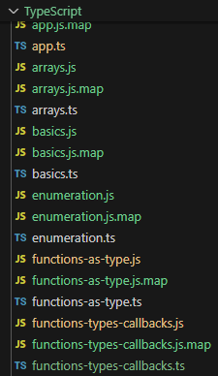

these wierd .js.map files act as a bridge between modern browsers and devtool to connect javascript files to input files

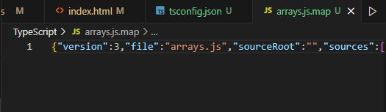

now we can see .ts files are also in our browser devtool

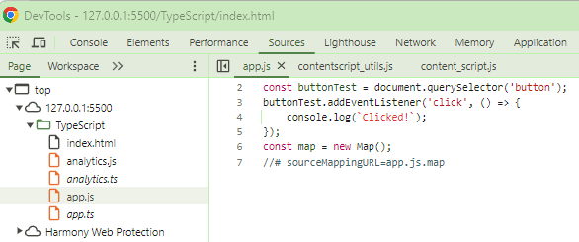

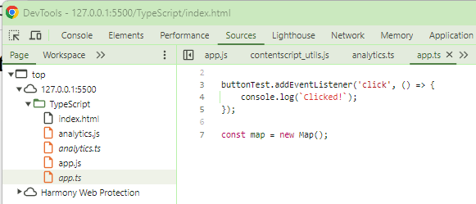

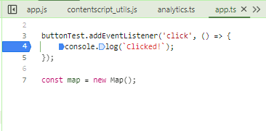

rootDir & outDir

Friday, April 5, 2024

1:48 PM

projectFolder/dist = outDir

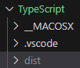

projectFolder/src = ts files

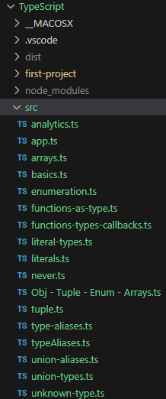

Specify rootDir for input files (.ts files) to ./src

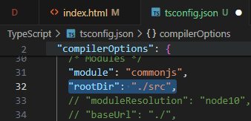

Specify outDir (.js files) to ./dist

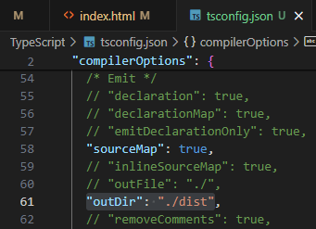

tsc to test compile & see whether .js files are in ./dist

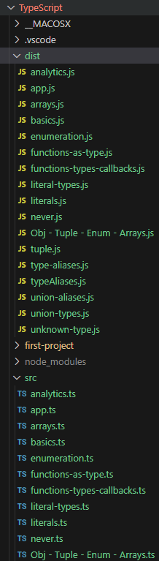

remeber to edit index.html

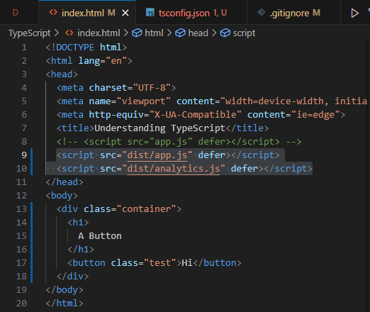

If loops are looking strange in compiled output files,

try to enable "downlevelIteration": "true" in tsconfig.json

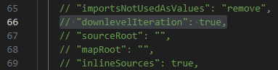

Do not compile .ts files with errors

Uncomment "noEmitOnError": "true"

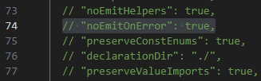

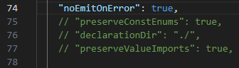

strict mode

Friday, April 5, 2024

5:12 PM

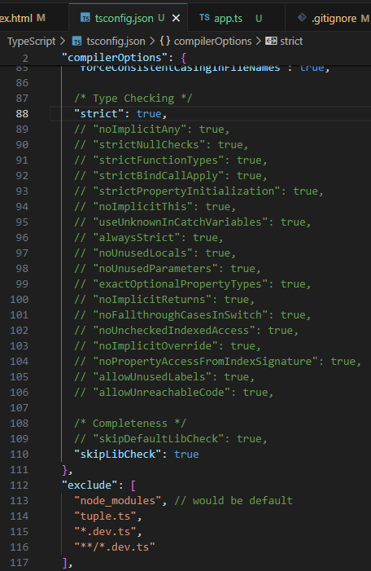

either setting "strict": true,

OR

setting all others separately

===

**Error out any types variables**

"noImplicitAny": true,

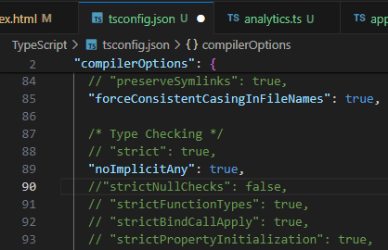

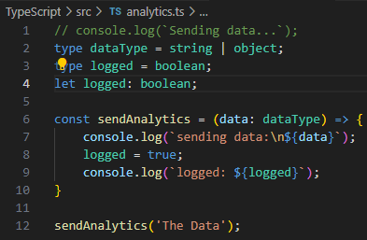

===

**Potentially Null value will NOT prompt error even without !**

**"strictNullChecks": false,**

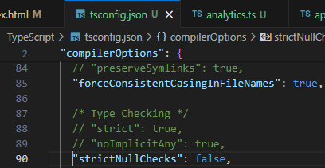

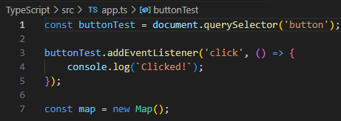

**"strictNullChecks": true,**

wrapping **DOM elements** with **if () {...}**

to make sure callbacks get called only if a DOM element exists

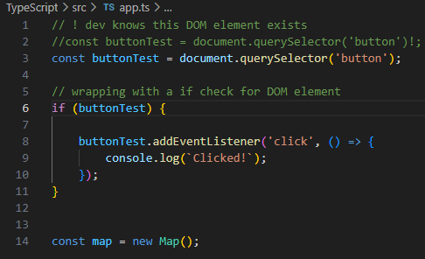

using an ES6 callback to listen to click events

callback.bind(input);

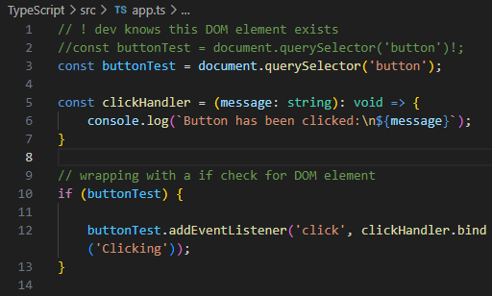

**strict-bind call checking**

**"strictNullChecks": true**

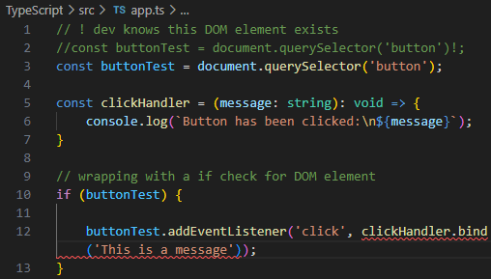

callback.bind(null) will trigger a strict-bind call error

**"strictNullChecks": false**

will ignore callback.bind(null) errors

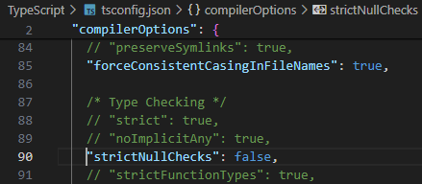

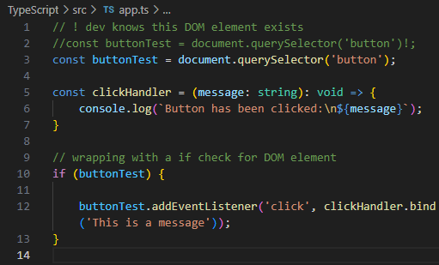

using **"strictBindCallApply": true**

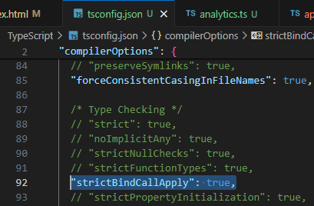

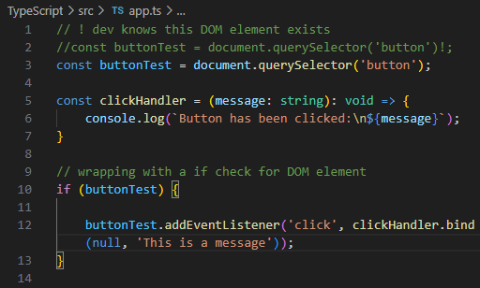

code quality options

Friday, April 5, 2024

5:48 PM

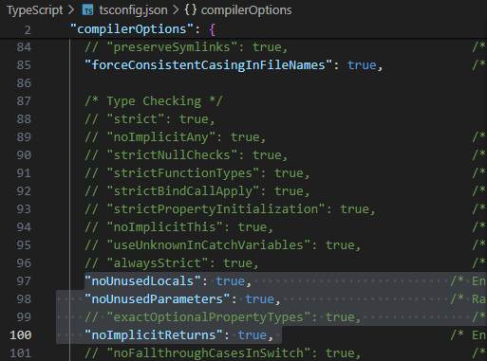

**"noUnusedLocals": true** =>

checks for **unused declared var in functions**

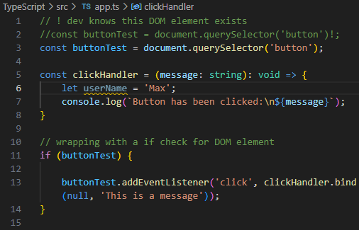

**"noUnusedParameters": true**

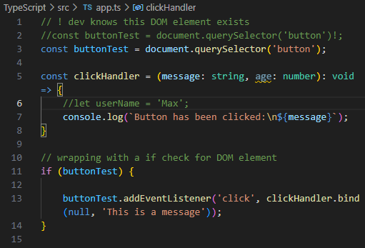

vscode debugging

Saturday, April 6, 2024

6:48 PM





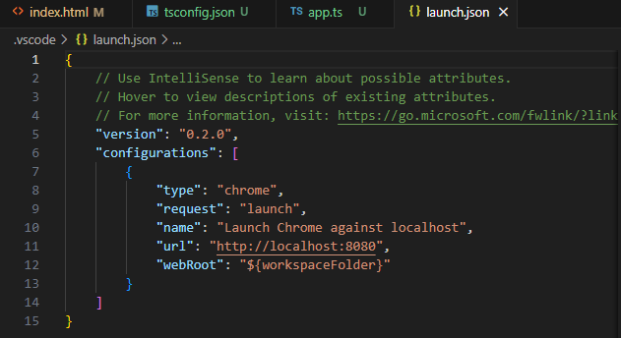

point to dev server port 5500 (live-server)

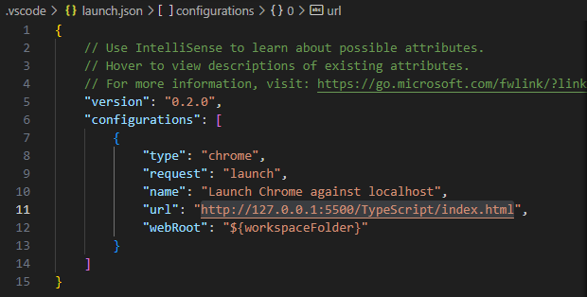

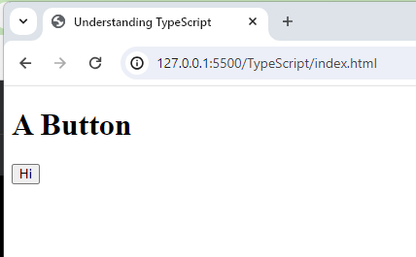

click step into



We'll have access to Script > this & Global

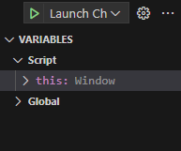

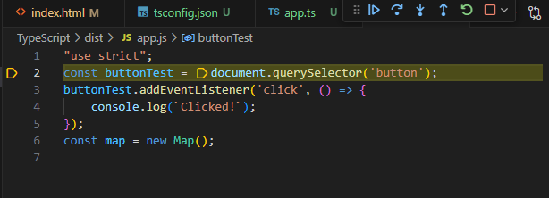

tsconfig.json

Saturday, April 6, 2024

8:06 PM

<https://www.typescriptlang.org/docs/handbook/tsconfig-json.html>

=== Next-gen JavaScript & TypeScript

Saturday, April 6, 2024

9:58 PM

Module introduction

Saturday, April 6, 2024

9:58 PM

let

const

const var = () => {...}

const copiedPerson = { ...person }

[...]

ret parameters

Arrays & Object Destructuring

ES6 tables

<https://compat-table.github.io/compat-table/es6/>

=== Classes & interfaces

Saturday, April 6, 2024

10:02 PM

creating a Class in ts

Saturday, April 6, 2024

10:02 PM

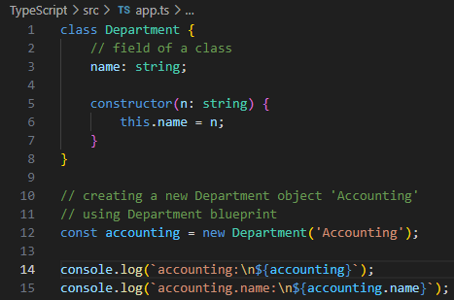

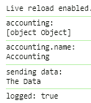

constructor functions & "this" keyword

// Creating another class accountingCopy

// using class destructuring

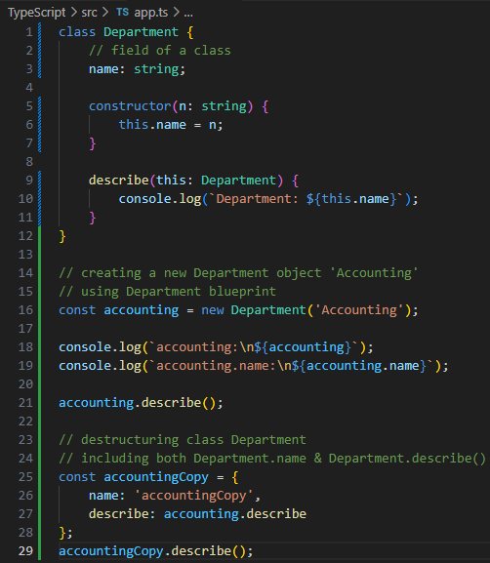

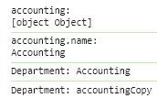

// Adding more keys & methods to class Department

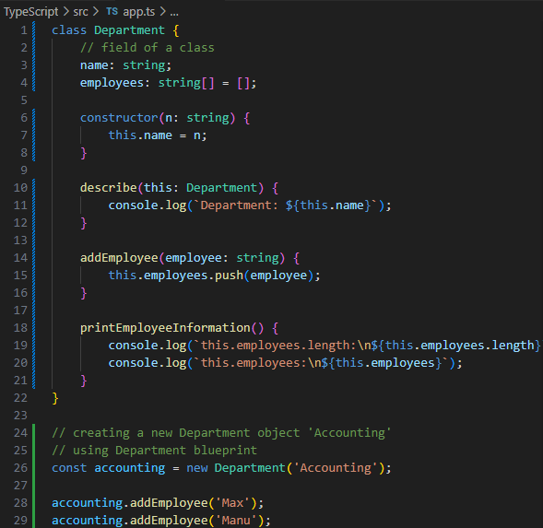

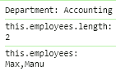

// Restricting access to accounting.employees

// using private keys

// accounting.employees[2] = 'Anna';

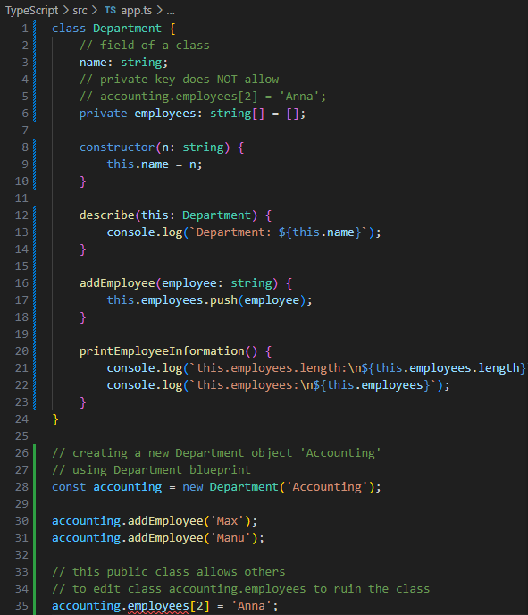

short initialization of class fields

Sunday, April 7, 2024

1:15 AM

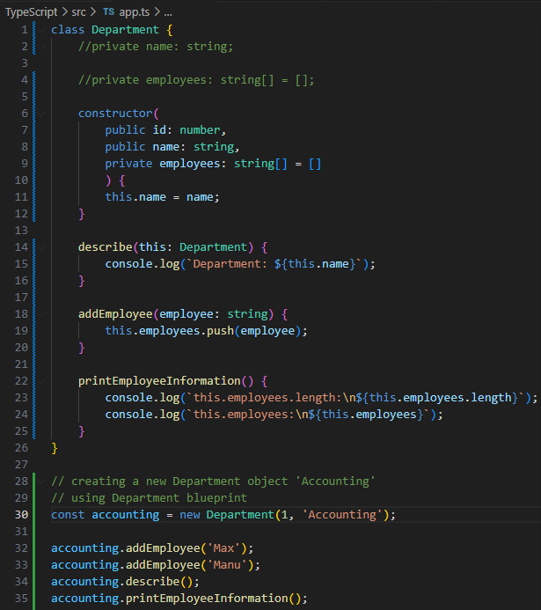

declaring public/private fields using constructor(...) {}

class className {

constructor(

public id: number,

public name: string,

private employees: string[] = []

) {

this.name = name;

}

}

// **readonly** class keys

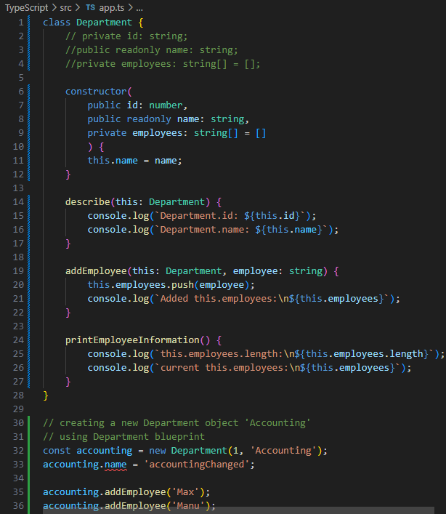

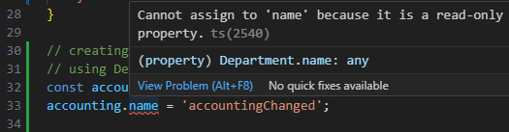

Inheritance

Sunday, April 7, 2024

1:32 AM

// blueprint

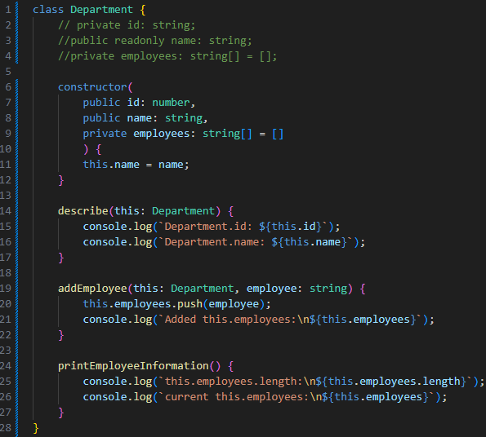

// creating another department 'IT'

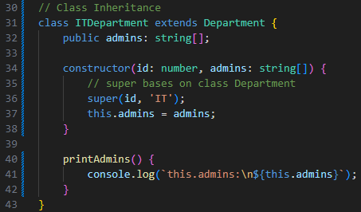

// creating it by concatenating new ITDepartment (class)

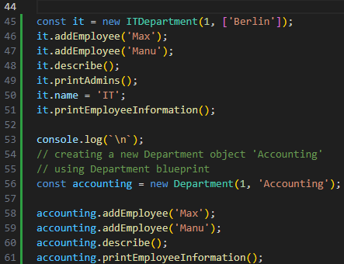

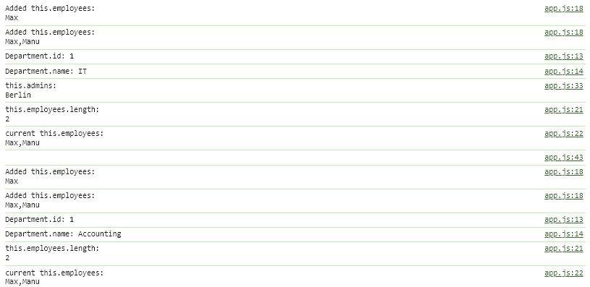

// re-creating accounting department using AccountingDepartment (class)

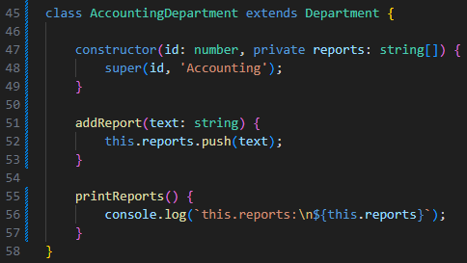

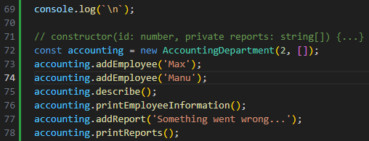

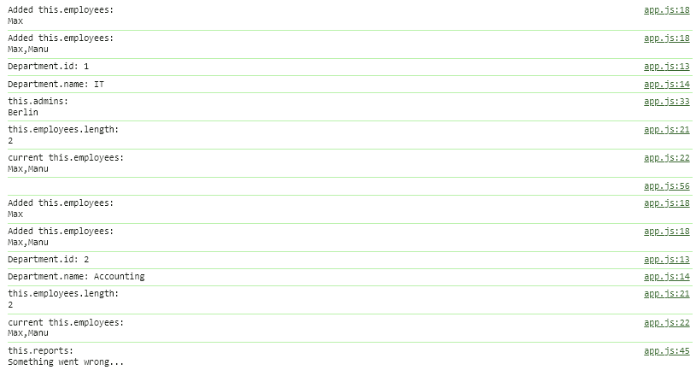

overriding properties & "protected" modifier

Monday, April 8, 2024

10:42 AM

// trying to add a method 'addEmployee' to class AccountingDepartment

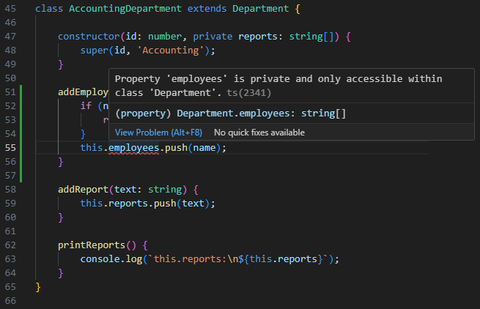

// because class AccountingDepartment **extends Department (inheritance)**

// and class Department's constructor(..., private employees: string[] = []) {...}

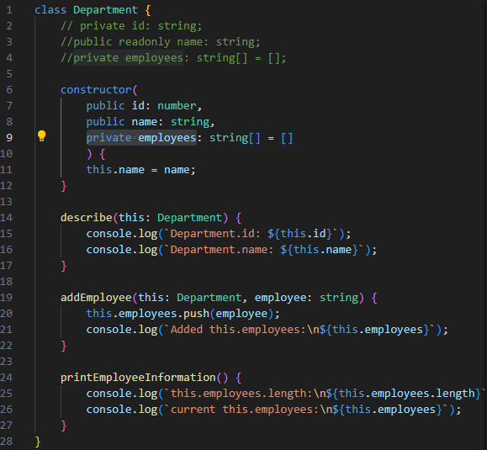

// using **protected** instead of **private**

// will allow other classes inheriting this class Department

// to amend this.employees

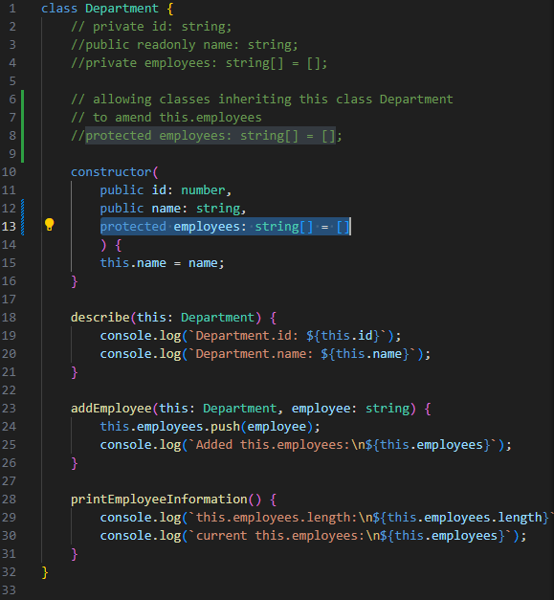

// now class AccountingDepartment extends Department {...}

// can amend this.employees

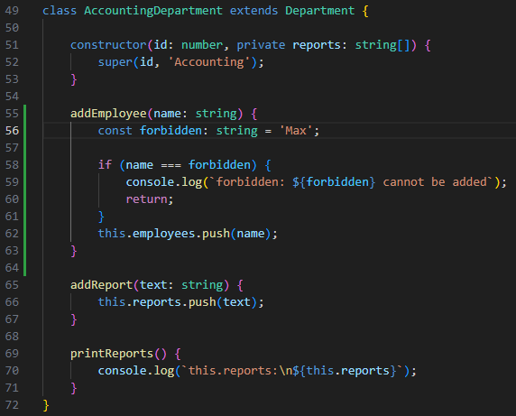

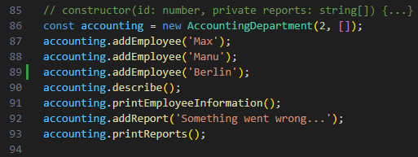

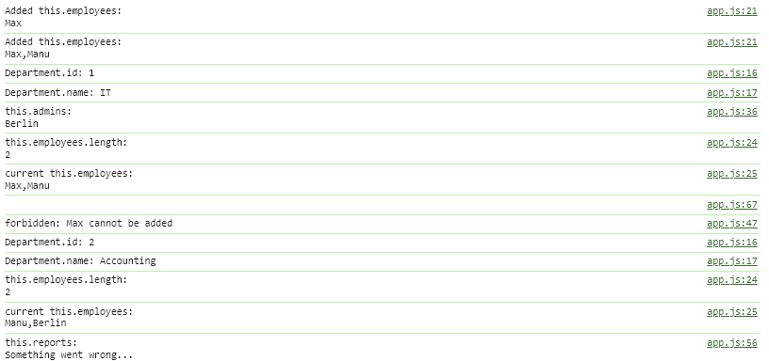

// getter method to gain access to private fields in a class

// by returning this.privateField to this class

// through closures hoisting

// just like writing a normal method before declaring constructor() {...}

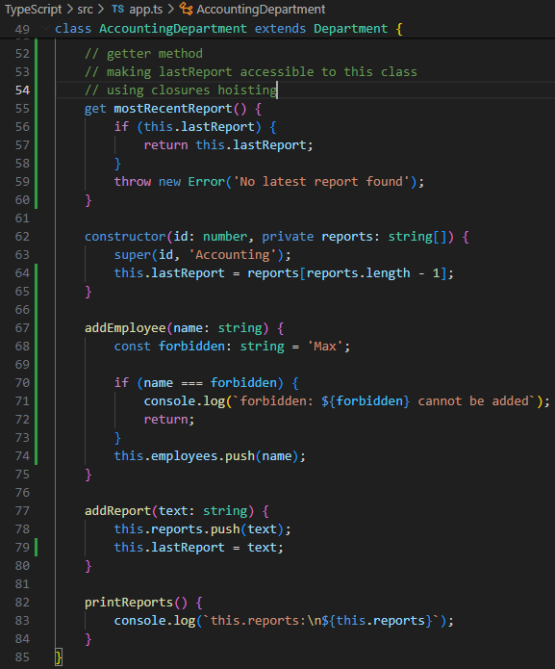

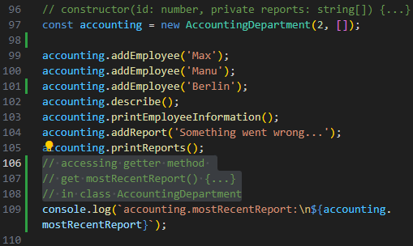

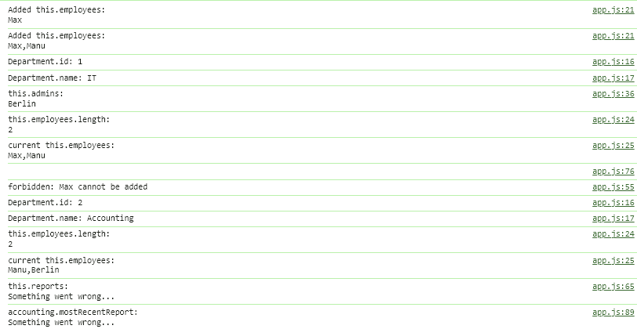

// setter method to gain access to amend class.fieldValue

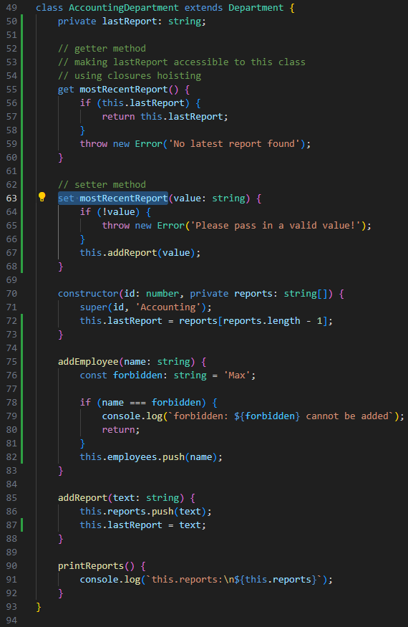

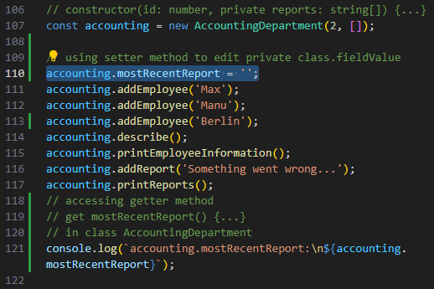

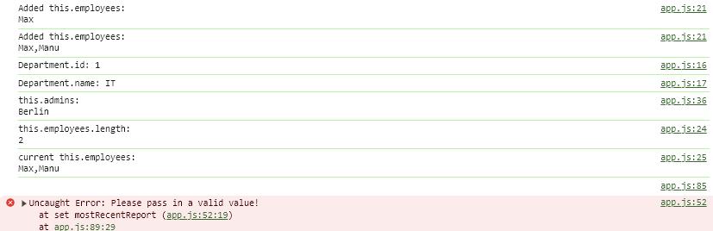

// using setter method in class

// to set class.fieldValue in class AccountingDepartment

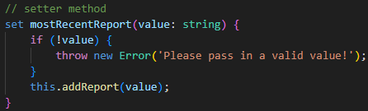

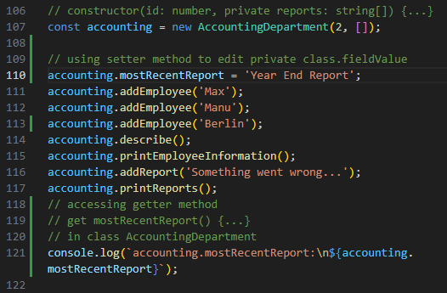

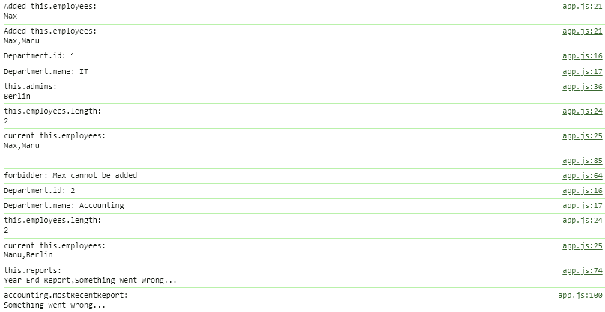

static methods & properties

Monday, April 8, 2024

11:49 AM

// a static method allows all inheriting sub-classes to call class.method()

// without instantiating our custom class

// e.g.

// const itEmployee1 = ITDepartment.createEmployee('itEmployee1');

// const accountingEmployee1 = AccountingDepartment.createEmployee('acEmployee1');

// usage

// const itEmployee1 = ITDepartment.createEmployee('name1');

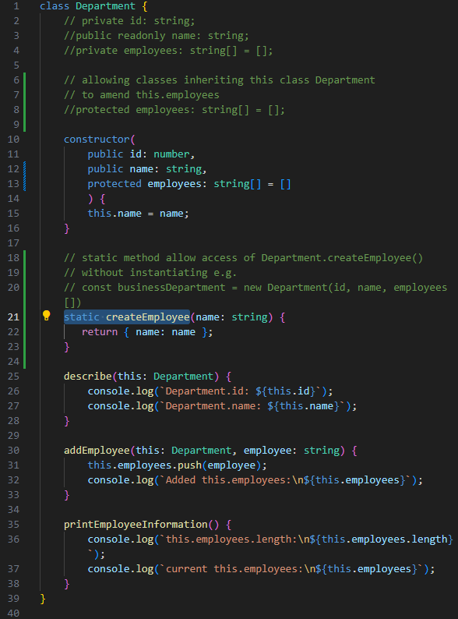

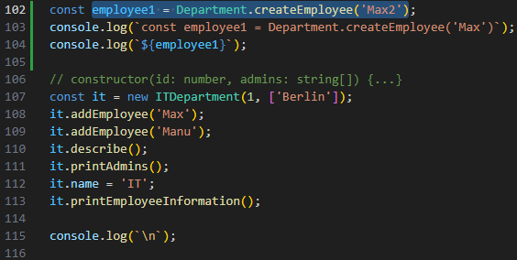

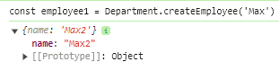

// adding a static field fiscalYear to class Department {...}

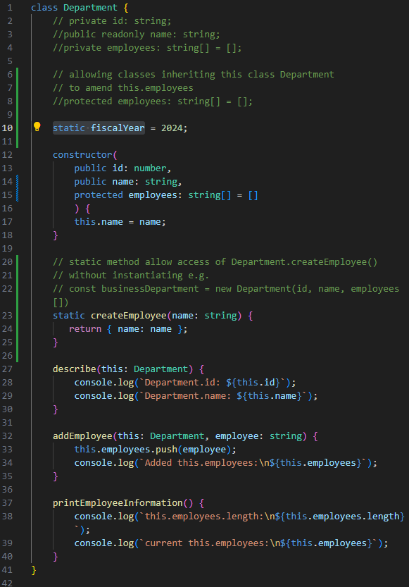

// then we can access Department.fiscalYear without instantiating

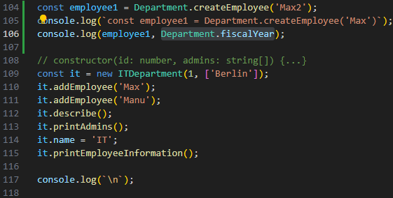

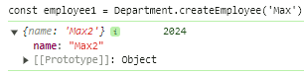

// all static properties & static methods are detached from instances

// cannot use this.fiscalYear to access a static property

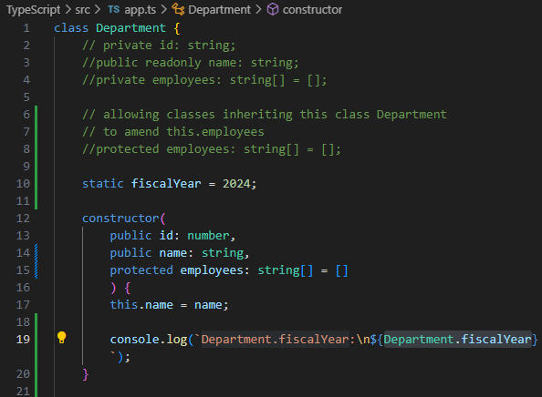

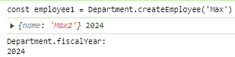

// example2 **static property**

// inheriting classes (sub-classes) calling static field from base class

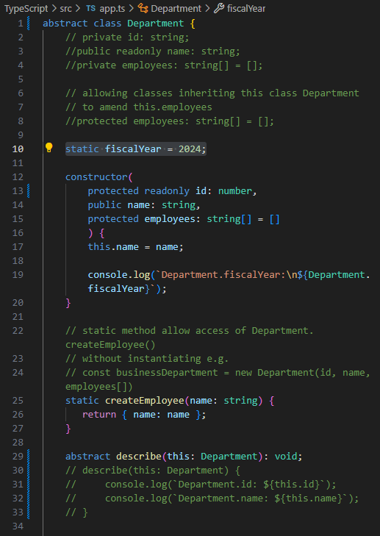

// sub-class ITDepartment extends Department

// also inherits static fiscalYear = 2024;

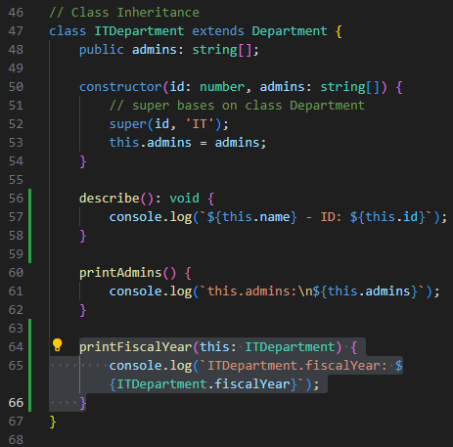

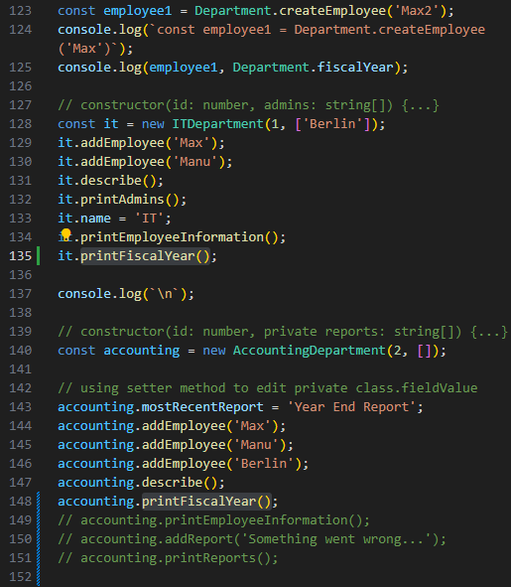

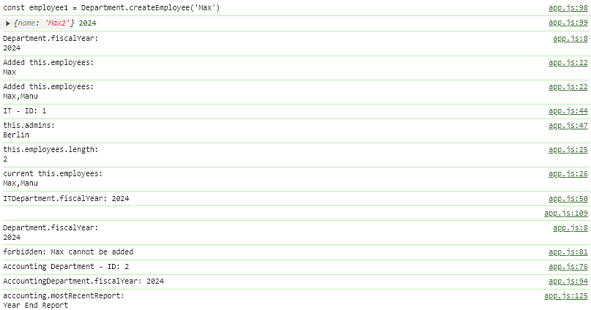

// example3 **static method**

// **do NOT need to instantiate a class**

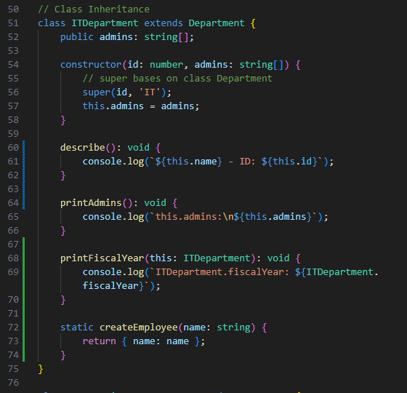

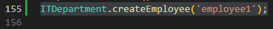

abstract class

Monday, April 8, 2024

2:15 PM

// allow sub-classes to inherit abstract properties/methods from base class

// NO explicit abstract properties' values should be made

// NO explicit abstract method () { code } should be made

// sub-classes to declare explicit values/code in abstract class.properties/class.method

// **abstract class cannot be instantiated itself**

// e.g. const ITDepartment = new Department(id, 'name', employees[]);

// **No explicit code** in **abstract properties/methods**

// abstract describe(this: Department): void;

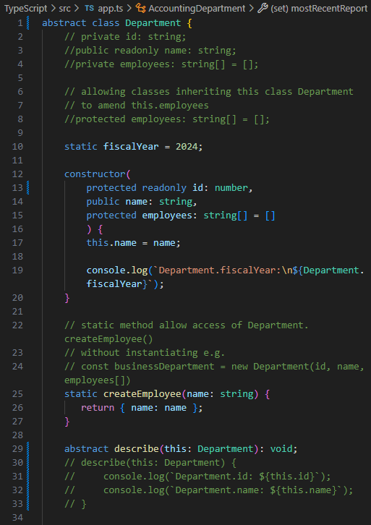

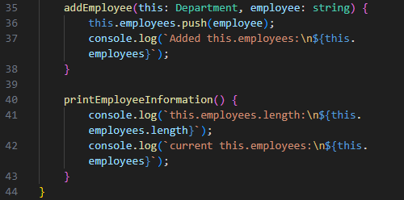

// correct usage of abstract class

class ITDepartment extends Department

// inheriting classes **must implement abstract method** from base class

e.g.

describe(): void { code... }

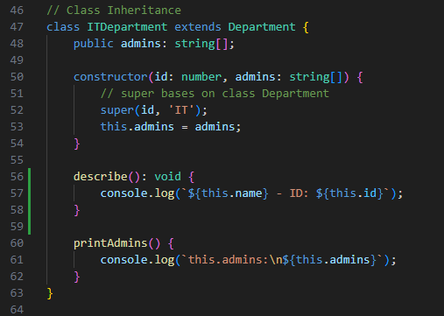

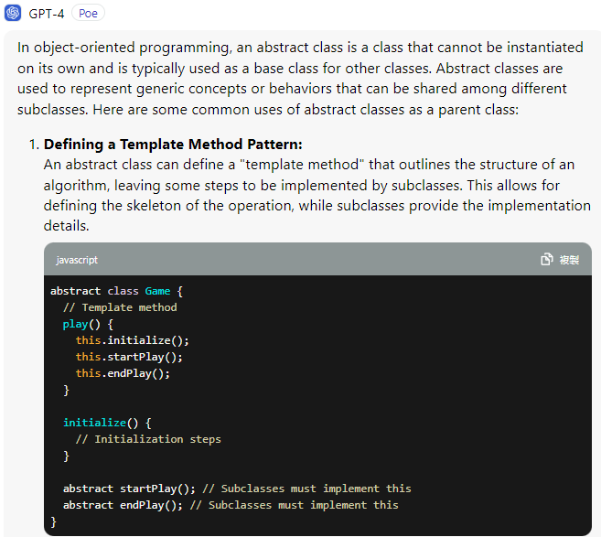

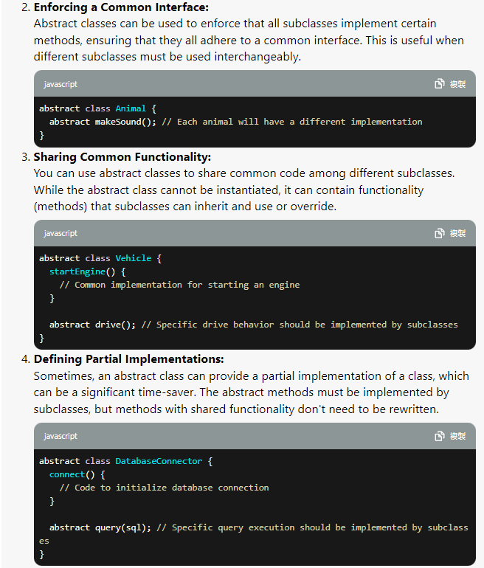

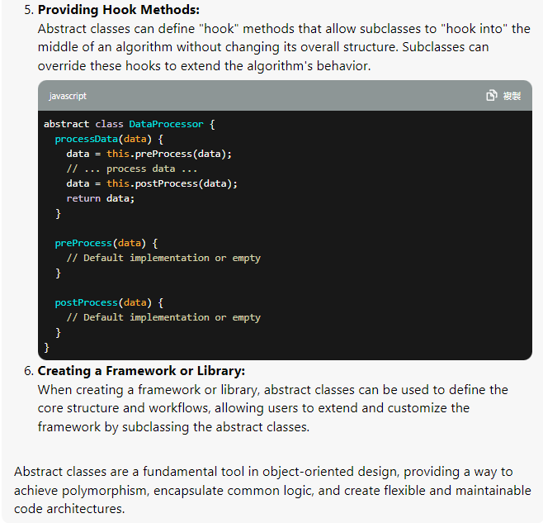

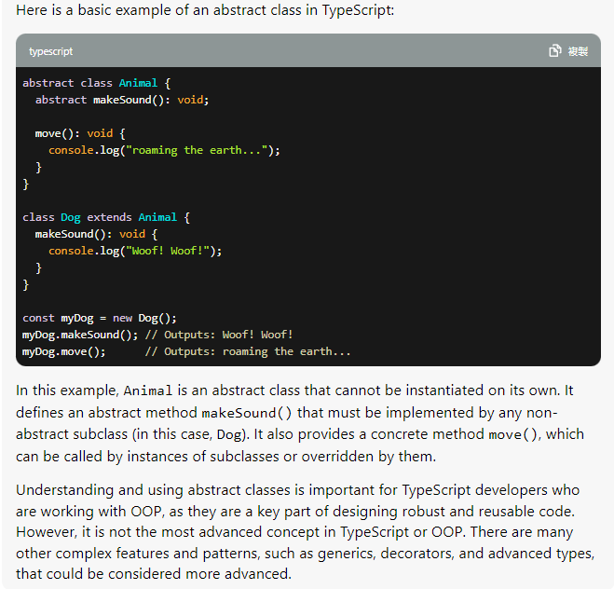

// parent abstract class Department

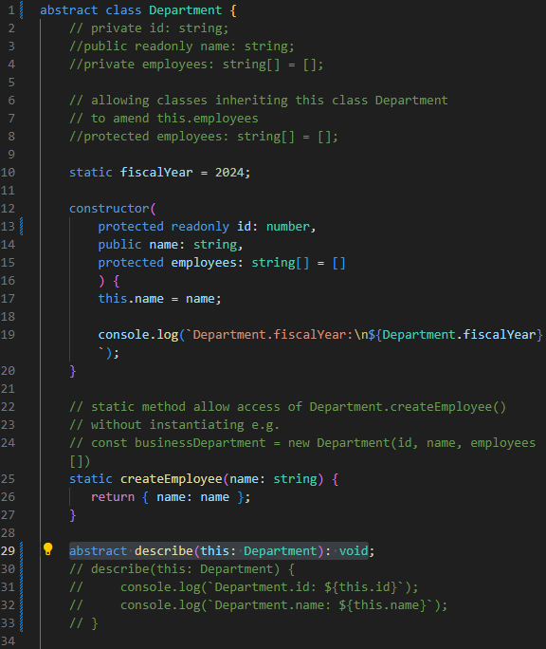

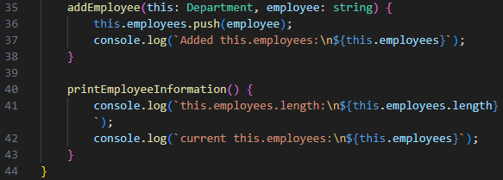

// children class ITDepartment extends Department

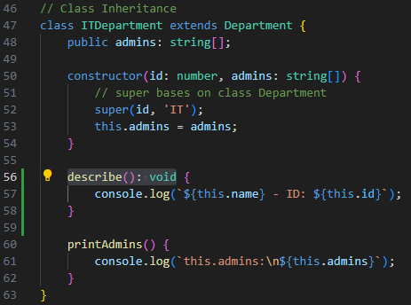

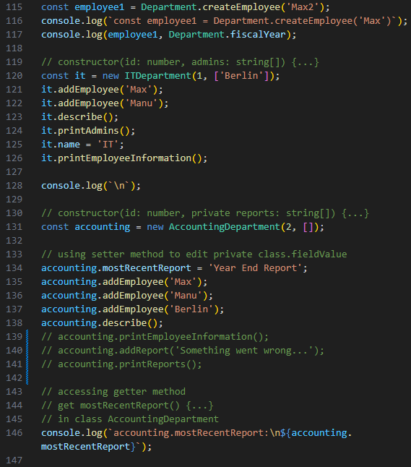

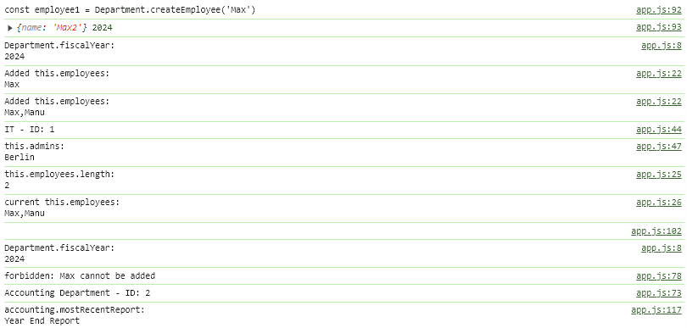

Singleton design pattern & private constructors

Monday, April 8, 2024

5:19 PM

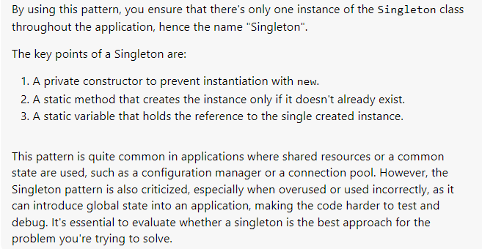

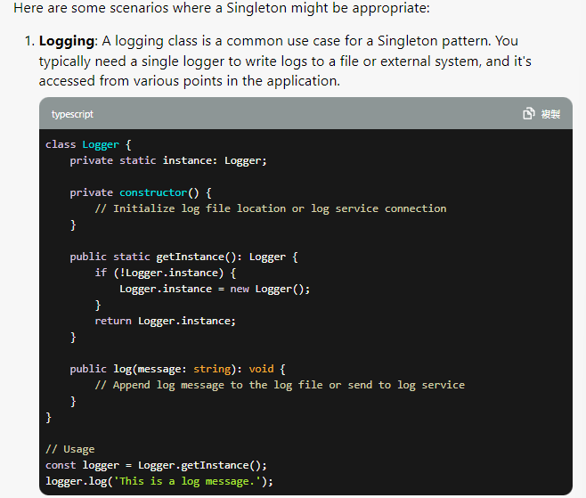

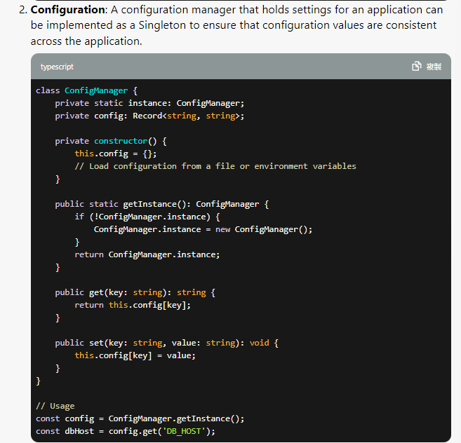

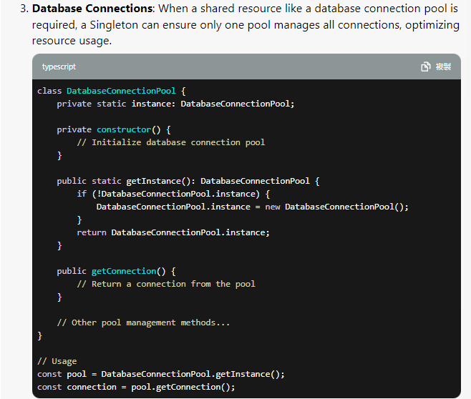



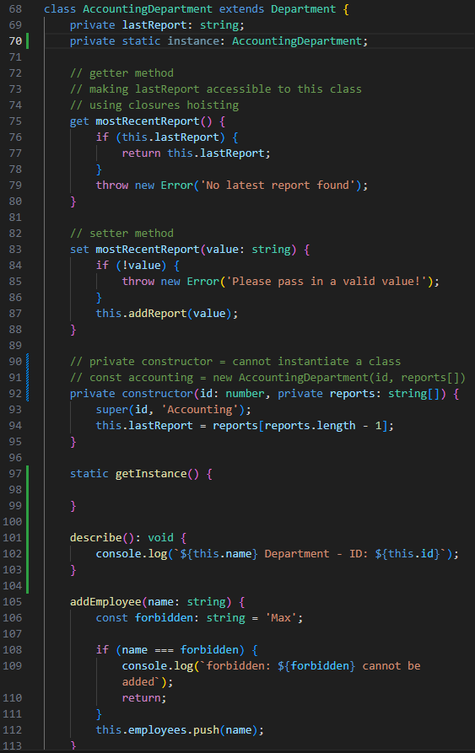

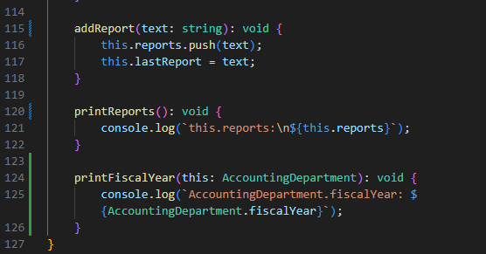

// cannot instantiate outside the class AccountingDepartment

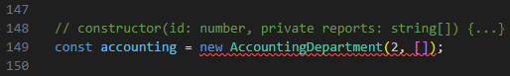

// check if AccountingDepartment.instance property is declared

// if true => return this.instance;

// otherwise, instantiate class AccountingDepartment within itself

// return this.instance to class

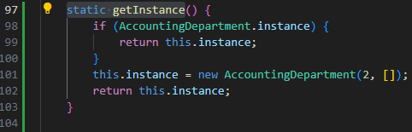

// use class.staticMethod(); to instantiate class AccountingDepartment

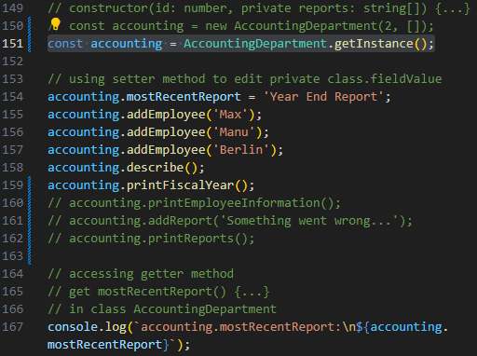

Interfaces

Tuesday, April 9, 2024

10:55 AM

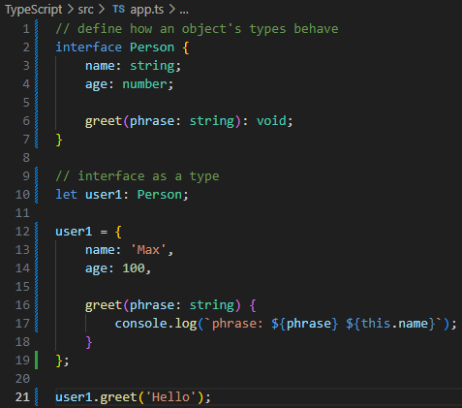

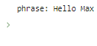

Implementing an interface inside a Class

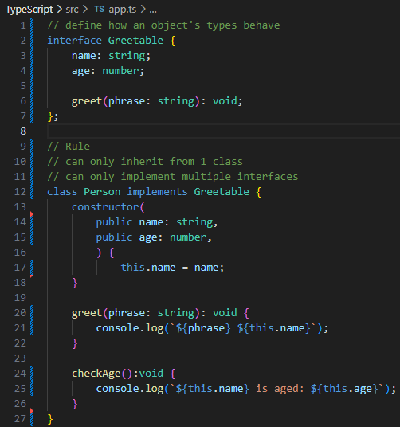

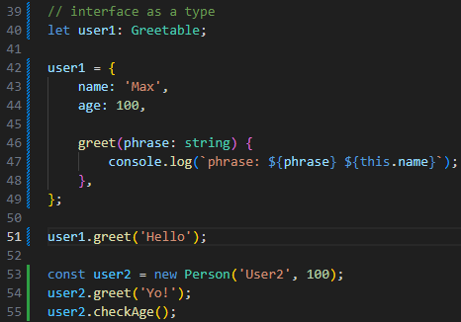

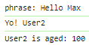

// comparing user1 & user2

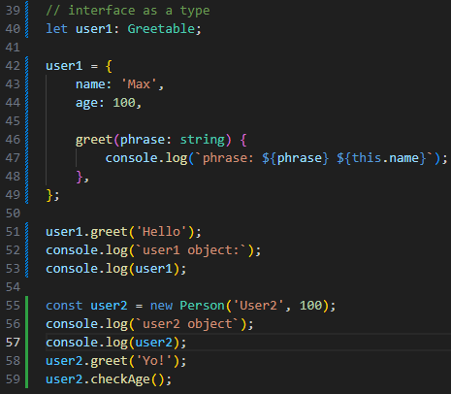

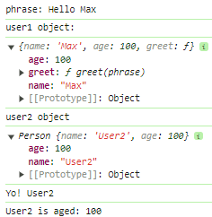

Why Interfaces?

Useful when we have a certain set of functionalities

e.g.

We wanna ensure class Person also has a greet(phrase: string): void

declared in interface Greetable

& other class might also have this greet(phrase: string): void too

which can force the existence of greet(phrase: string): void

**To share common functionality among classes safely**

**each sub-class must implement all methods stated in interface**



**readonly modifier**

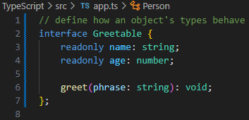

**interfaces cannot use public/private properties**

sub-classes implementing interface Greetable can **only initialize readonly properties** (name & age) **once upon class instantiation**

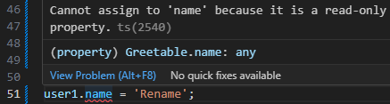

**Extending Interfaces**

interface Greetable extends Aged, Named {...}

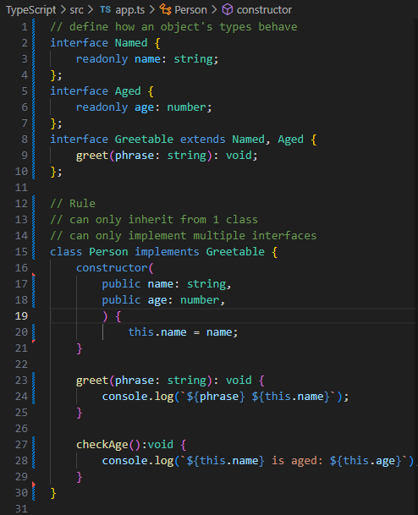

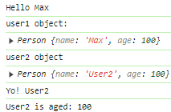

**Interfaces as Function Types**

// using interface to define structures of a function

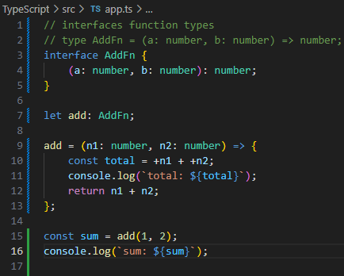

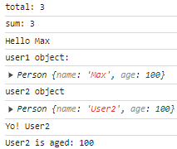

**Optional parameters & properties**

**deep-dive continue next slide**

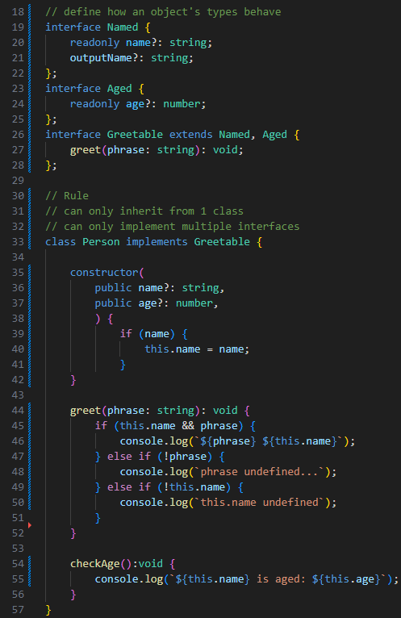

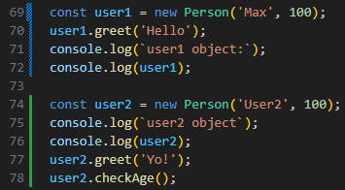

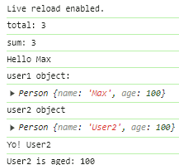

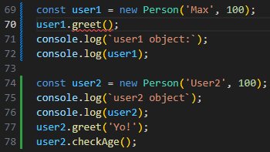

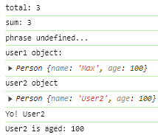

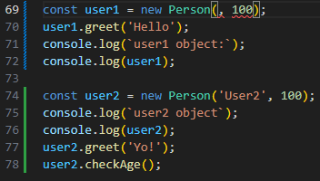

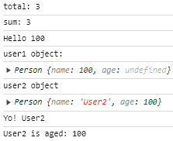

optional parameters & optional properties

Tuesday, April 9, 2024

8:13 PM

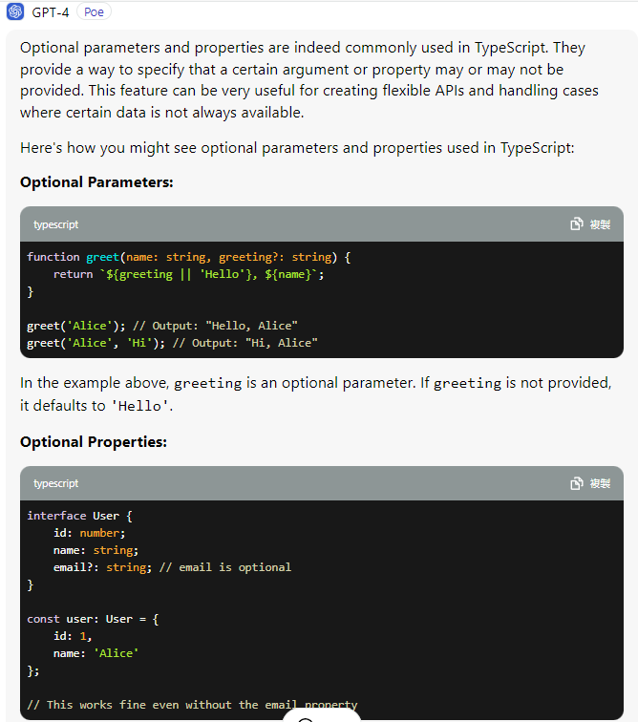

// example1

// all parameters are parsed

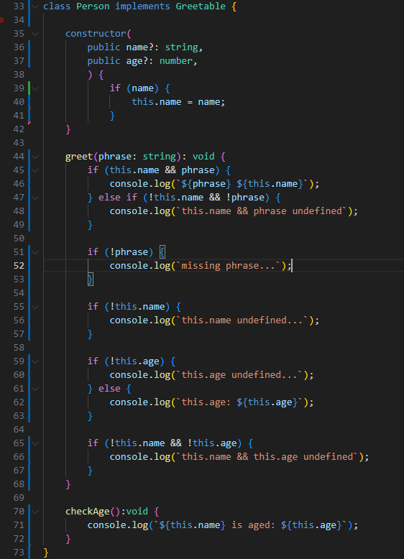

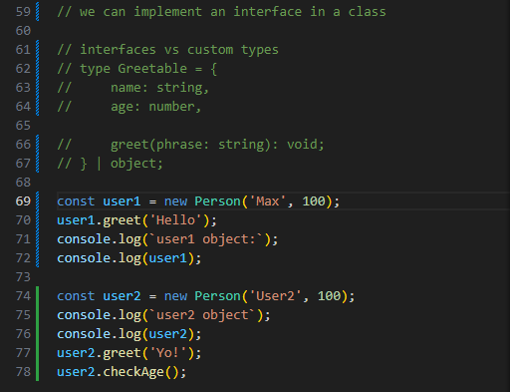

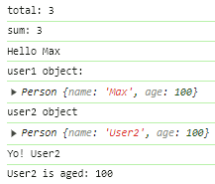

// example2

// missing parsed name & age

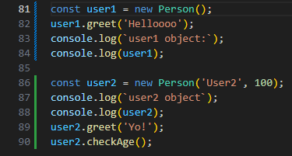

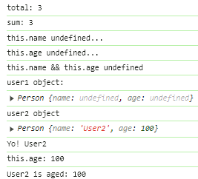

// example3

// missing parsed age

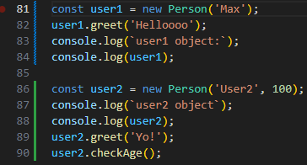

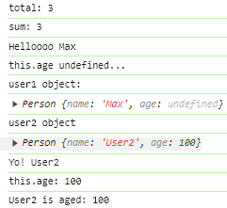

// example4

// missing parsed name

// parsed age becomes name

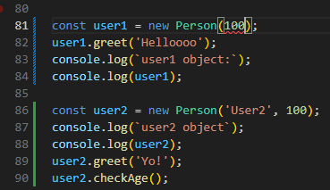

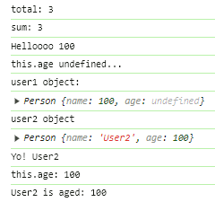

// example5

// missing parsed phrase

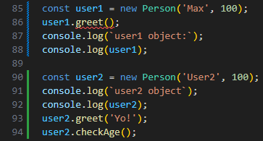

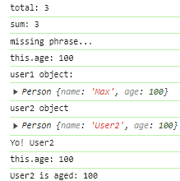

compiling interfaces to JavaScript

Tuesday, April 9, 2024

10:07 PM

**TypeScript interfaces are NOT compiled at runtime to Javascript**

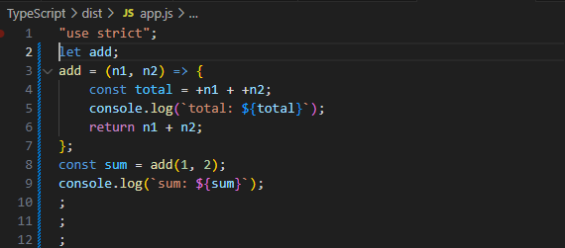

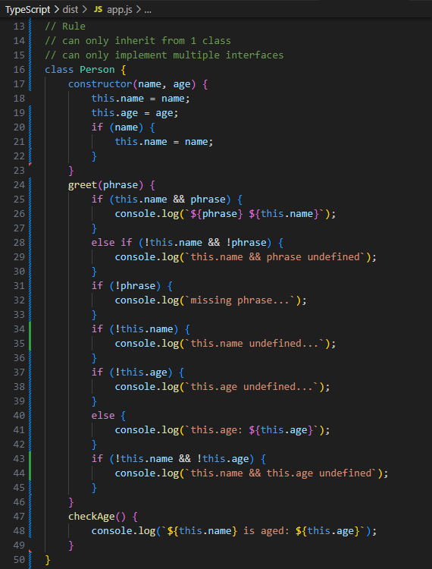

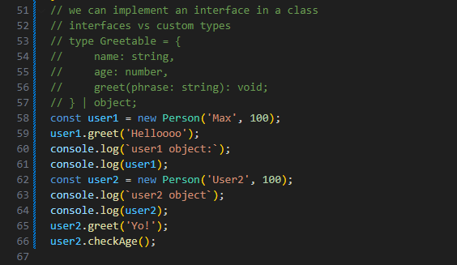

<https://www.typescriptlang.org/docs/handbook/2/objects.html>

=== Adv. Types

Wednesday, April 10, 2024

10:13 AM

i. Intersection Types

ii. Type Guards

iii. Discriminated Unions

iv. Type Casting

v. Function Overloads

Intersection Types

Wednesday, April 10, 2024

10:55 AM

// Approach1

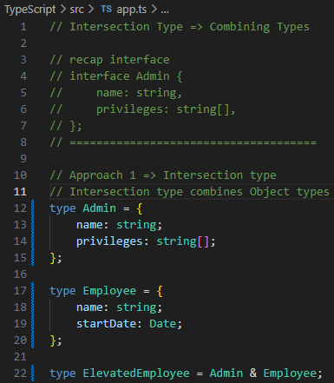

// Approach2

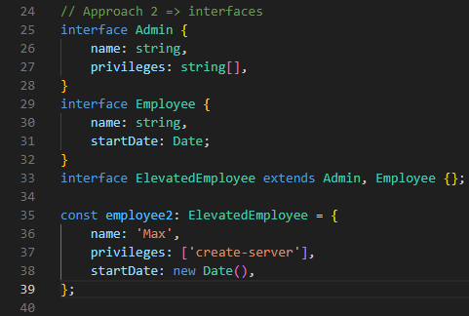

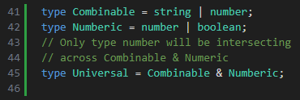

type guard

Wednesday, April 10, 2024

12:13 PM

**Type Guards**

**to check whether a property(s) or a method(s) exist in an Object**

example1

if typeof a === 'string' || typeof b === 'string'

force coersion +a + +b => number;

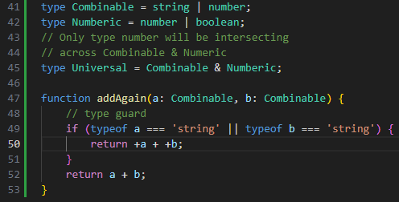

example2

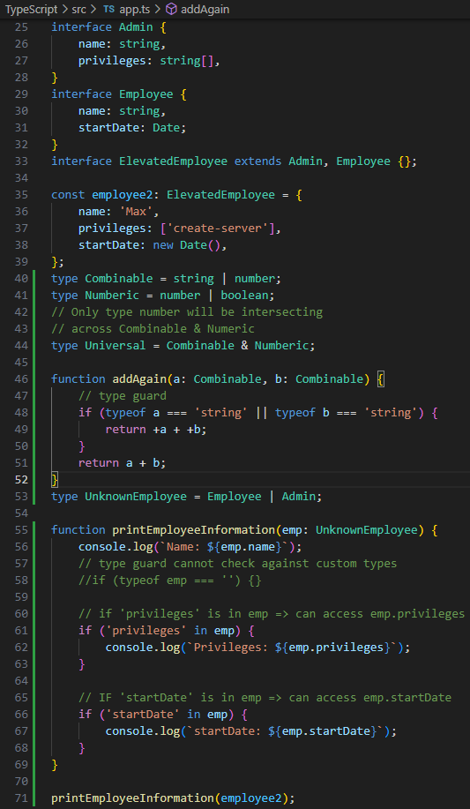

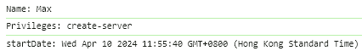

example3

creating employee2 on the fly without declaring an Object

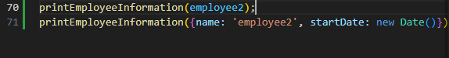

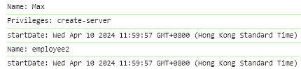

practice2

type guard **checks against** 'loadCargo' **method** in vehicle

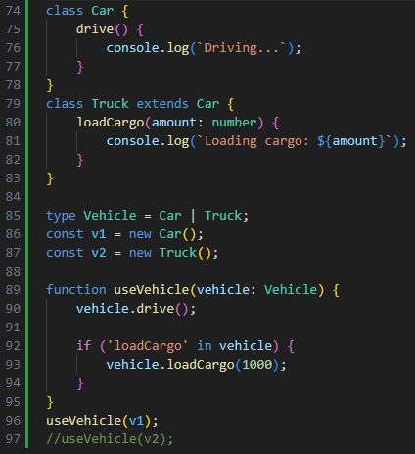



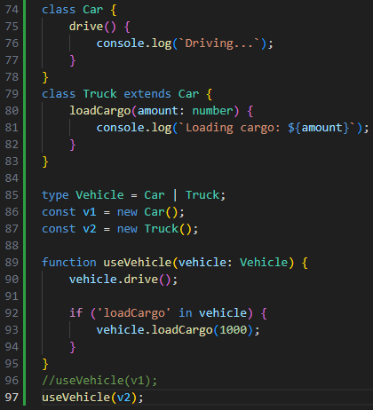

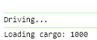

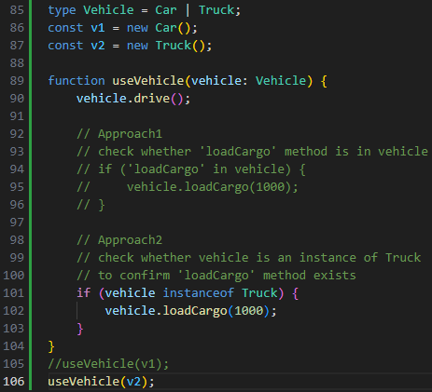

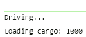

** discriminated unions

Wednesday, April 10, 2024

12:27 PM

// a **special type of type guard**

// pattern used to make implementation of type guards easier

// using 1 common property across interfaces

// that makes up the union (common property)

// as **interfaces are NOT compiled at runtime**

// we **cannot check against** whether parsed animal is an **instance** of

// any interfaces

// e.g.

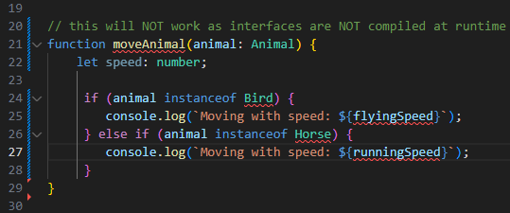

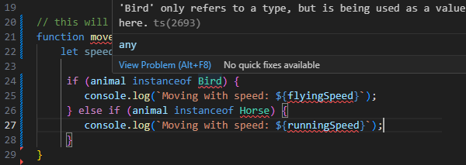

// using a **switch operator** to **check against** animal.type **common property**

// across multiple interfaces

// this **determines** which **interface.differentProperty** should be **used** animal.flyingSpeed / animal.runningSpeed

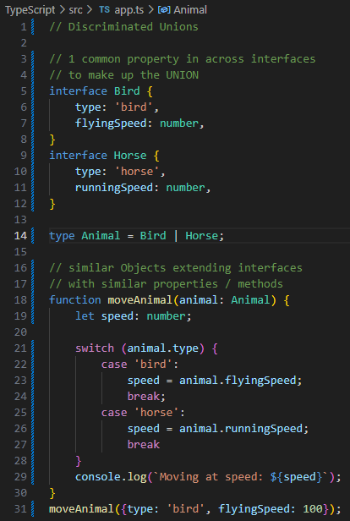



type casting

Wednesday, April 10, 2024

5:37 PM

// need Type Casting to edit HTMLElement object.properties

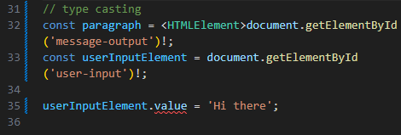

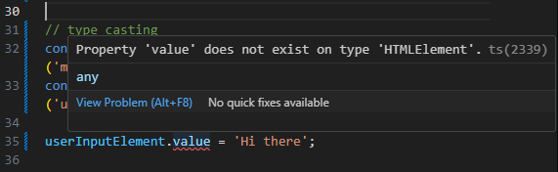

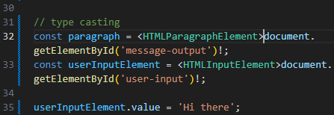

// Approach 1

// document.getElementById('')! as HTMLParagraphElement;

// Approach 2

// <HTMLInputElement>document.getElementById('')!;

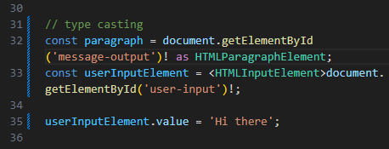

// Approach 3

// use object checking => type casting in if () {...}

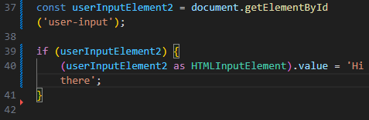

index type & index property

Thursday, April 11, 2024

10:17 AM

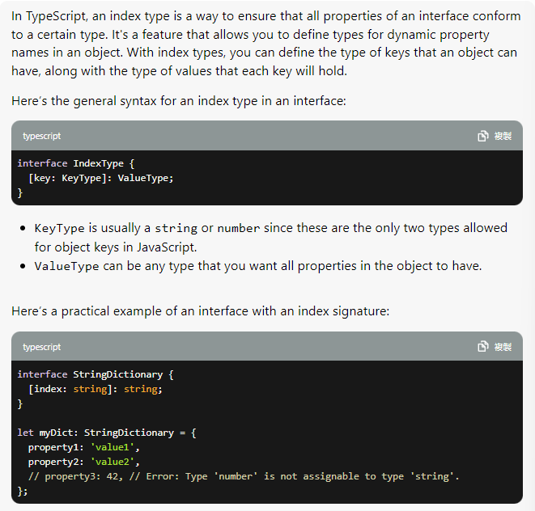

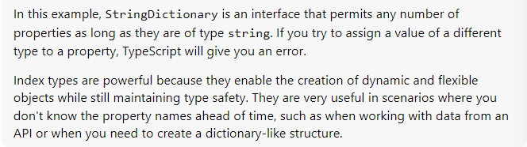

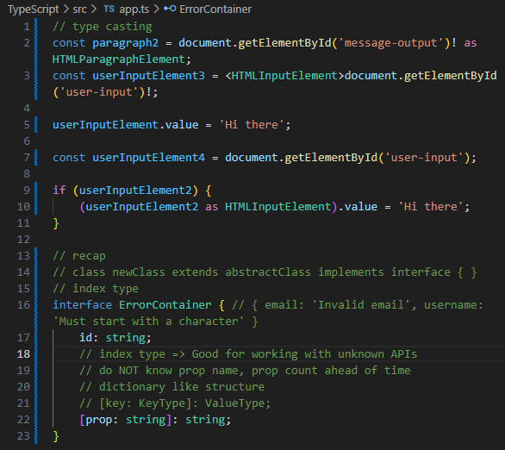

// declared index type limits the id: valueType

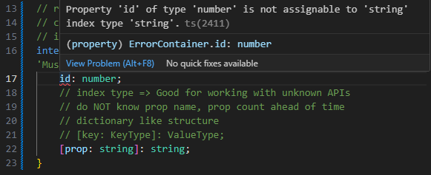

Syntax

[key: keyType]: keyValue

if changing keyType to number, string key => NOT work

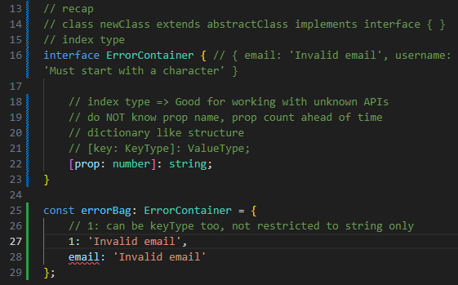

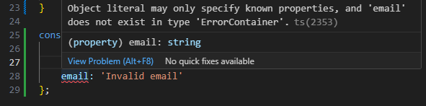

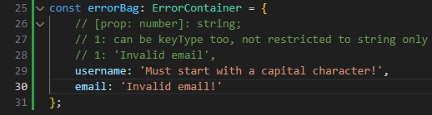

** function overloads

Thursday, April 11, 2024

11:52 AM

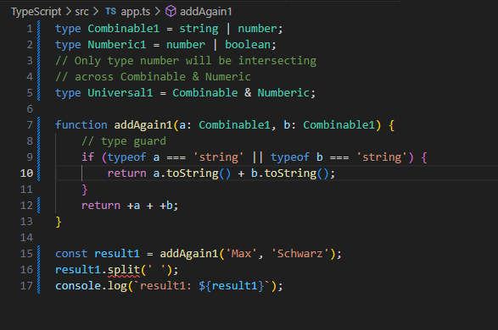

// const result: **number** => addAgain1('Max' ,'Schwarz');

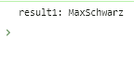

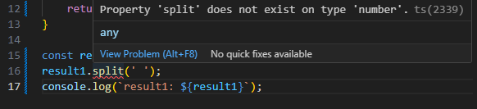

// adding type casting to allow result1.split();

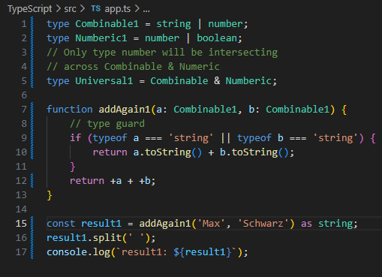

// **Function Overloading**

**// combining the powers of multiple knowledge bases of same function**

**// with different function types**

**// to allow a variety of parsed data into a function**

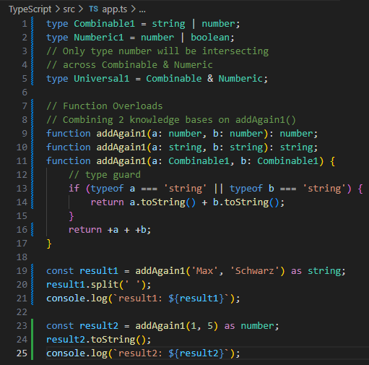

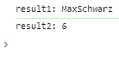

**// Function Overloading with 4 function types**

function addAgain1(a: **number**, b: **number**): **number**;

function addAgain1(a: **string**, b: **string**): **string**;

function addAgain1(a: **string**, b: **number**): **string**;

function addAgain1(a: **number**, b: **string**): **string**;

function addAgain1(a: **Combinable1**, b: **Combinable1**) {...}

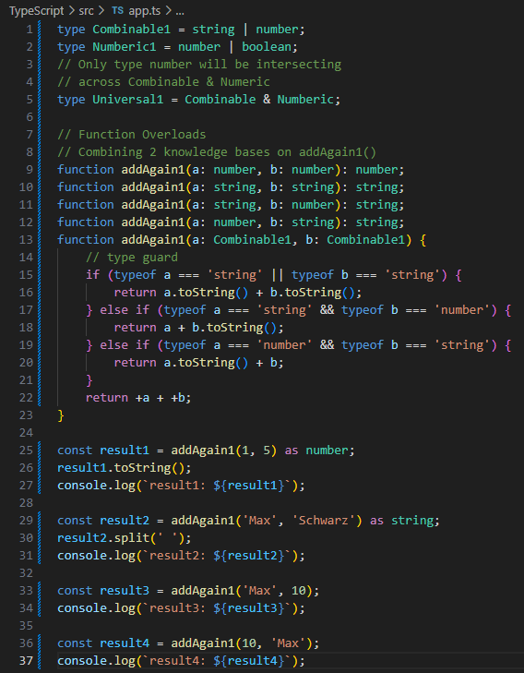

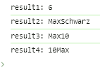

optional chaining ?.

Thursday, April 11, 2024

2:23 PM

// ?. useful when dealing with fetching database unknown object.properties

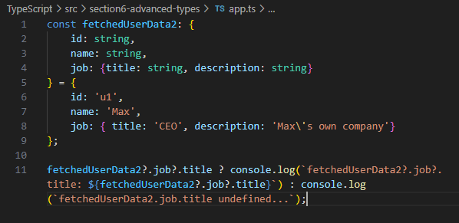



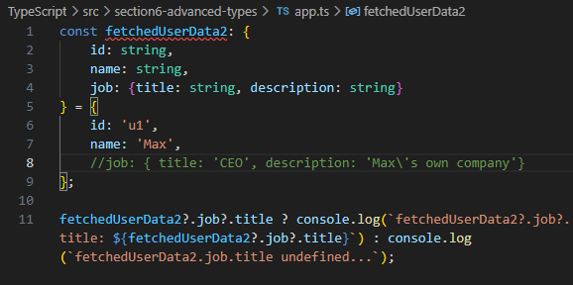

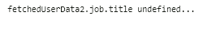

**Nullish Coalesing**

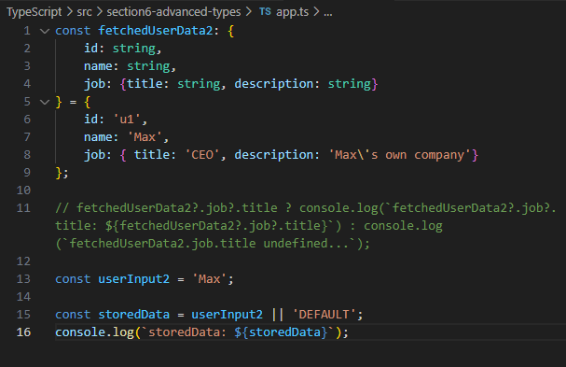



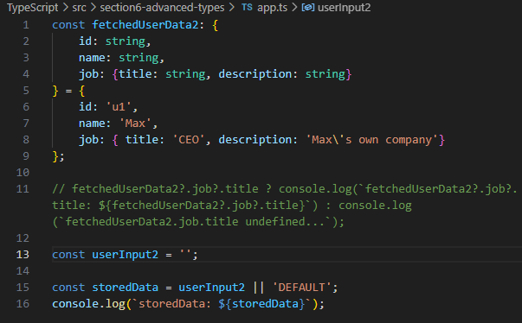

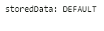

Nullish Coalesing

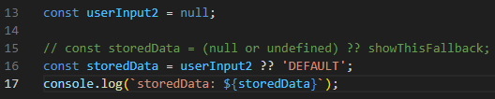

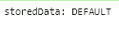

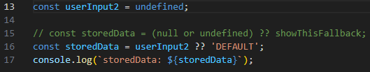



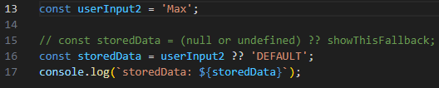



Adv. Type quiz

Thursday, April 11, 2024

2:54 PM

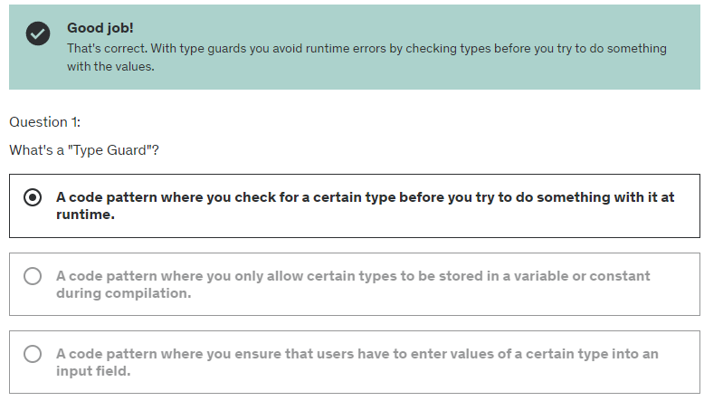

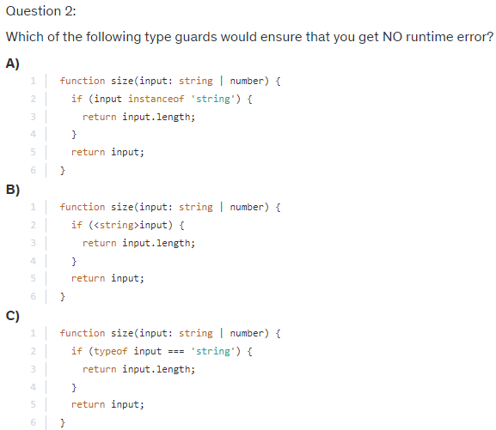



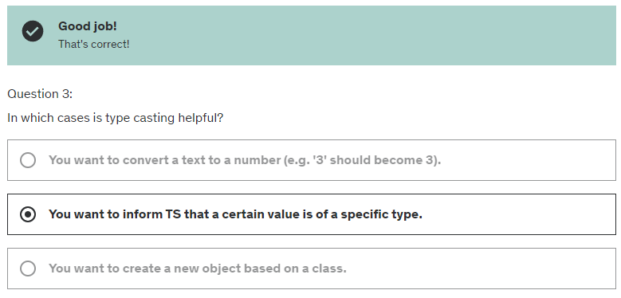

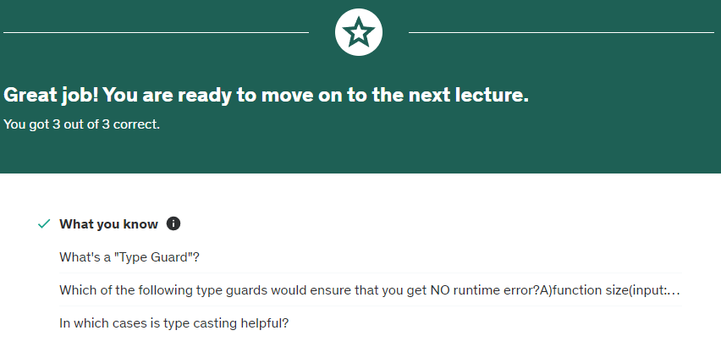

<https://www.typescriptlang.org/docs/handbook/2/types-from-types.html>

=== Generics

Thursday, April 11, 2024

2:59 PM

Only exists in TypeScript

- Generic Functions & Classes

- Constraints

- Special TypeScript Types

<https://developer.mozilla.org/en-US/docs/Web/JavaScript/Reference/Global_Objects/Promise>

explaining Generic built-in function

Friday, April 12, 2024

12:00 PM

// traditionally

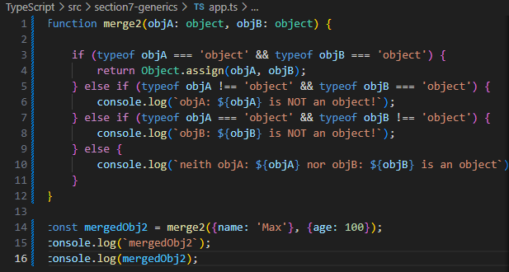

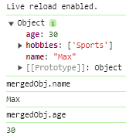

Creating a Generic function

Thursday, April 11, 2024

3:51 PM

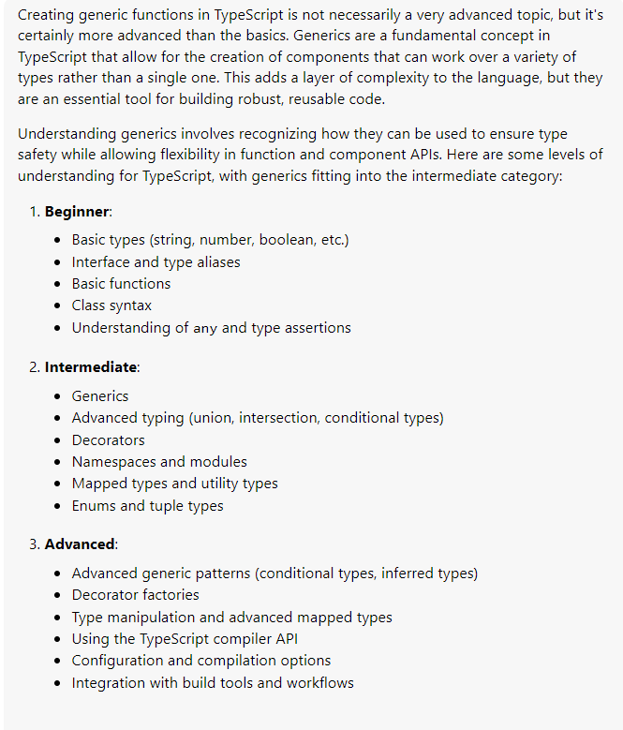

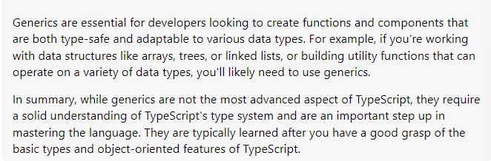

// **Creating** a **Generic** function to merge objects

// **Objects = highly unspecific types => any objects**

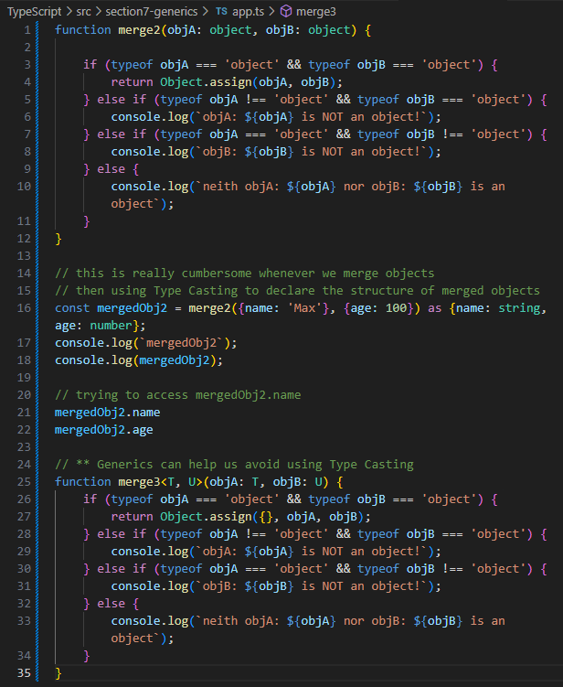

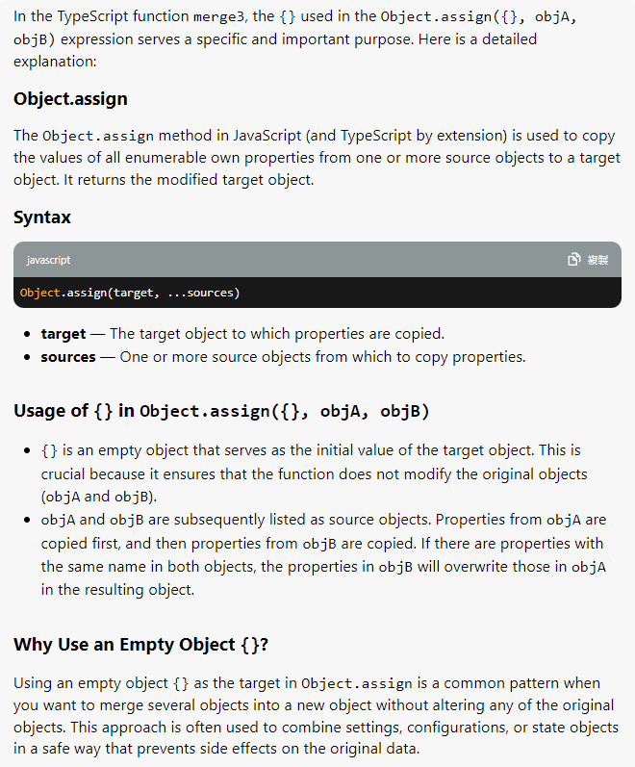

// if NO Type Casting => cannot access mergedObj.properties

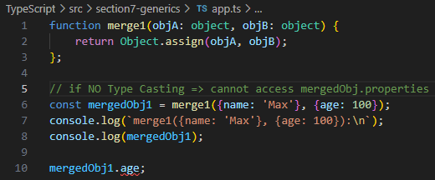

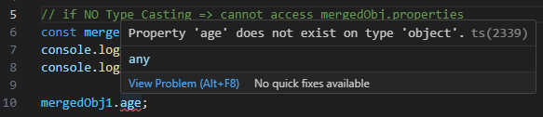

// however, using Type Casting is too cumbersome

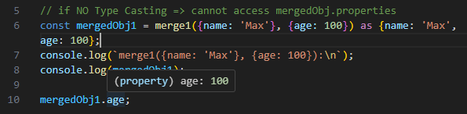

// creating our own Generic Function using Generic Types

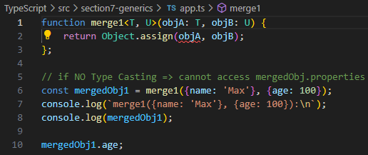

// reflecting the **Intersection of T & U**

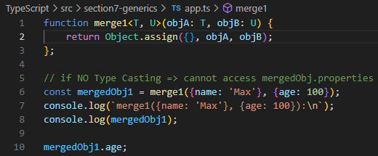

// TypeScript understands **objA will always be of different type to objB**

// by understanding the **intersection of T & U**

**// objA = a very specific Type**

**// objB = another very specific Type**

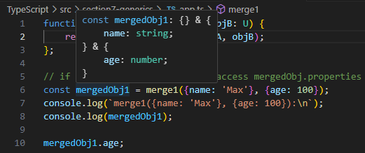

// **object is a highly unspecific type**

// the **intersection** of **2 unknow objects** = a **new unknown object**

// which does **NOT offer** any additional **info**rmation to **TypeScript**

// function merge1<T, U>(objA: **object**, objB: **object**): **object & object** {

return Object.assign({}, objA, objB);

};

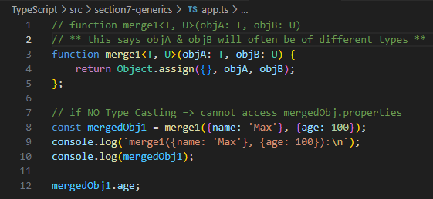

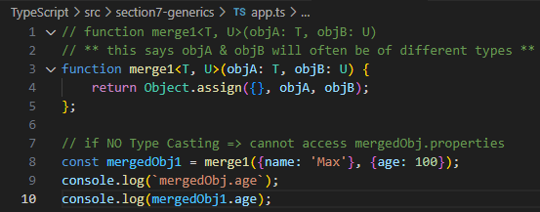



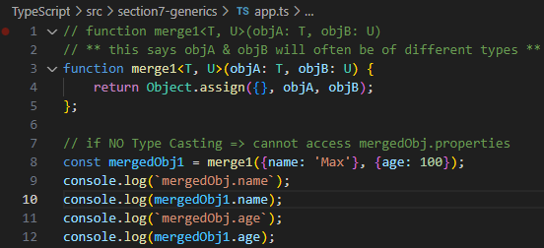

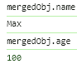

// objA || objB can be dynamically defined as of any Object Structures

// **very useful when dealing with dynamic Object assignments**

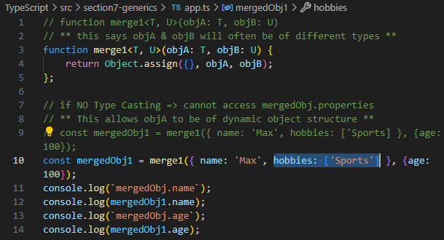

// T => { name: 'Max', hobbies: ['Sports'] }

// U => { age: 100 }

**Working with Constraints**

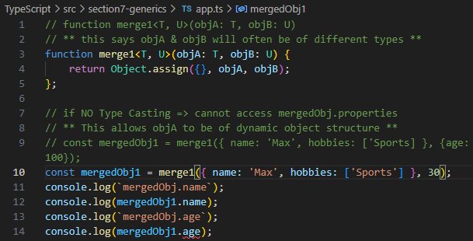

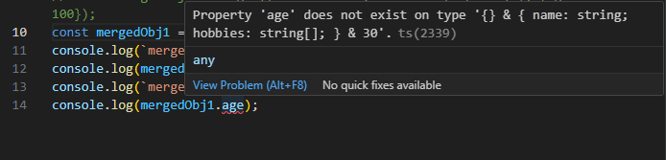

// age: 30 will be missing from mergedObj1

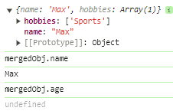

// ** adding type constraints

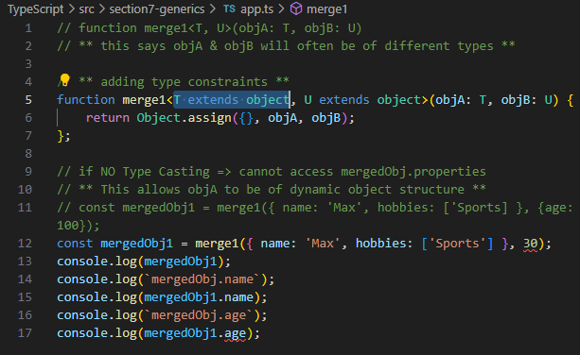

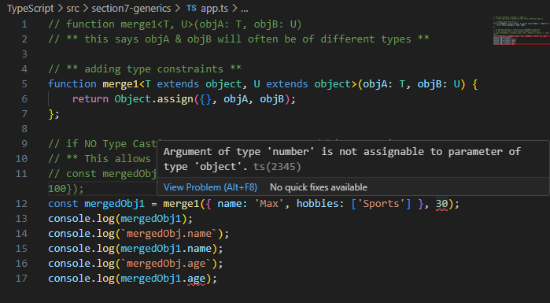

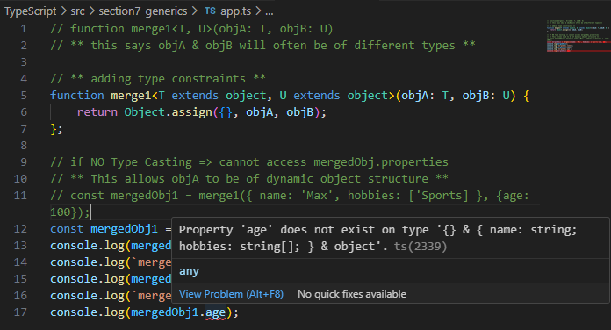

// this ensures we get 2 objects here

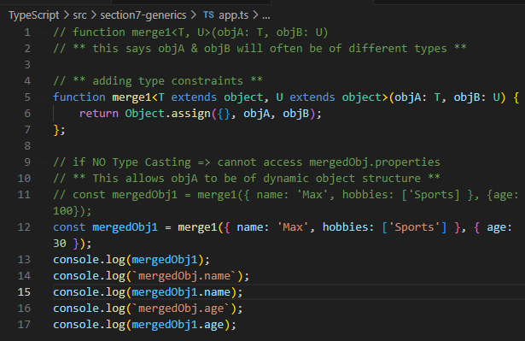

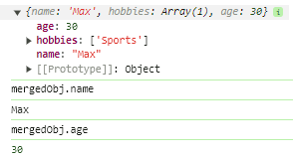

// thus now, we **can access mergedObj.name & mergedObj.age**

// **without Type Casting**

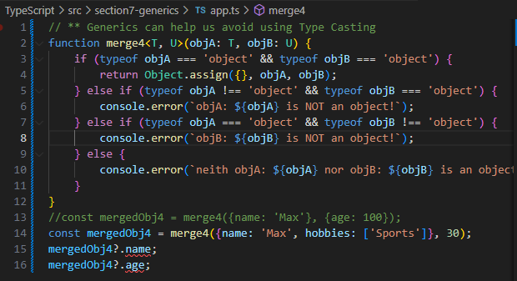

Generics

Thursday, April 11, 2024

3:13 PM

example1

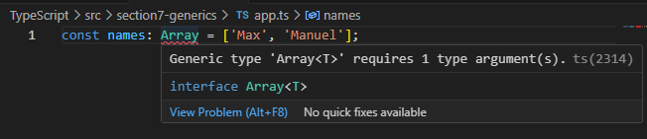

// a type connected to another type

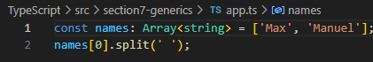

Main type: Array

return type: <string>

===

example2

main type: Promise

return type: <string>

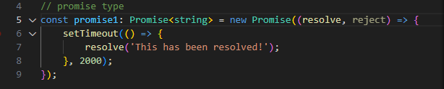

example3

main type: Promise

return type: <string> vs <number>

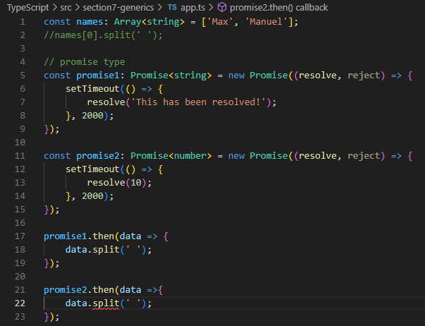

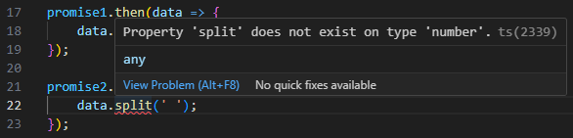

constraints

Friday, April 12, 2024

12:26 PM

// if we parse any non-object inputs to our Generic merge4<T, U>(objA: T, objB: U) {...}

// we'll receive errors



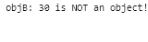

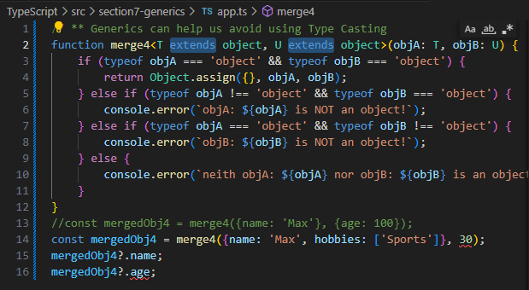

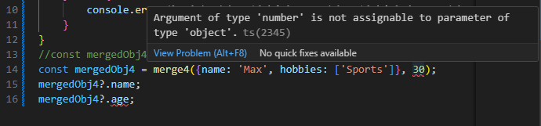

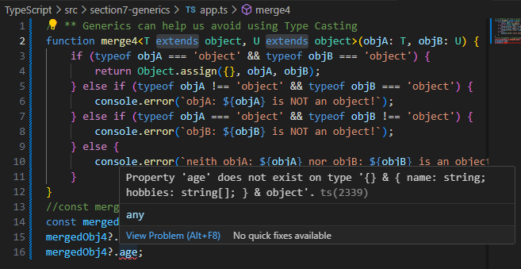

generic function types

Friday, April 12, 2024

1:00 PM

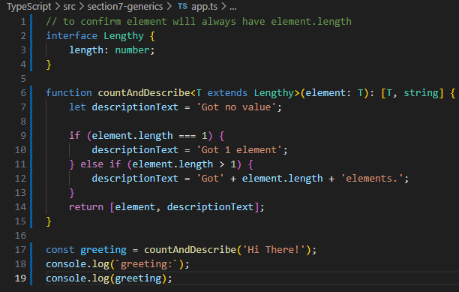

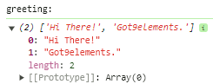

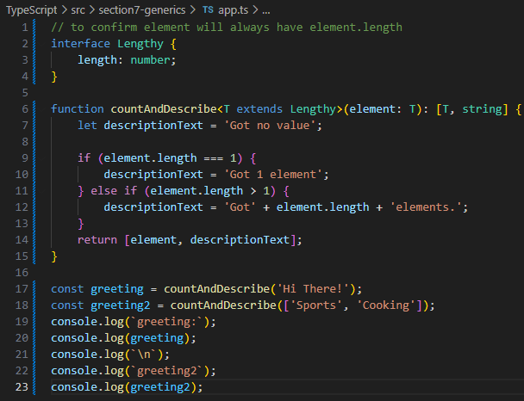

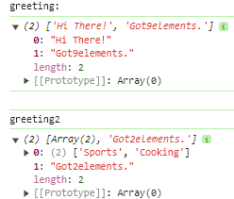

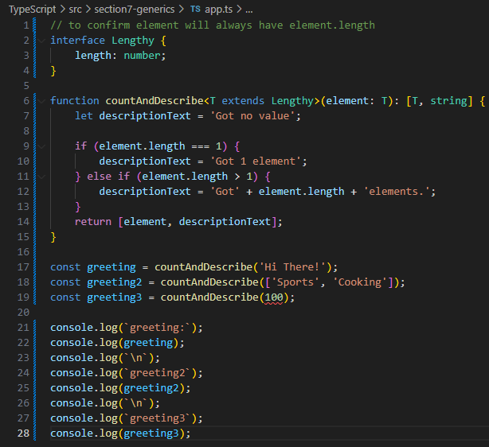

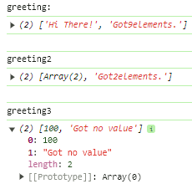

keyof constraint

Friday, April 12, 2024

11:53 AM

// trying to access an object's key value

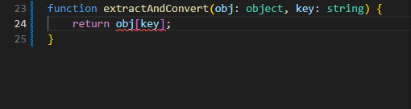

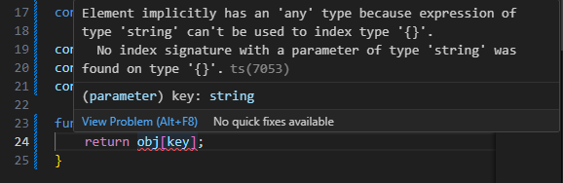

// creating a Generic function with <T extends object, U extends keyof T>

// **U has to be a key of T object**

function extractAndConvert<T extends **object**, U extends **keyof T**>(obj: T, key: U) {

return 'Value: ' + obj[key];

}

// an empty object {} will catch errors

extractAndConvert({}, 'name');

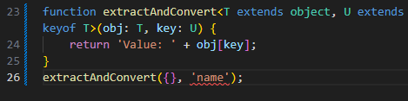

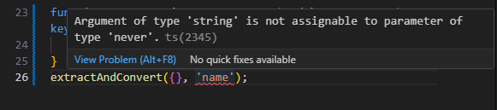

// this ensures a valid object {}, key are parsed to our custom Generic function

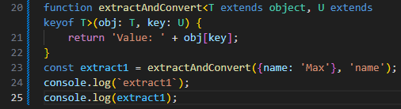

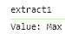

Generic Class

Friday, April 12, 2024

4:27 PM

// a Generic class ensures all parsed arguments in class.method() are Generic

// along with typeGuard => type safety

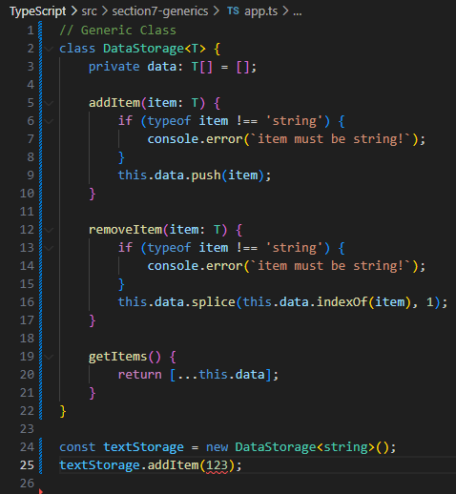

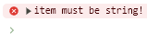

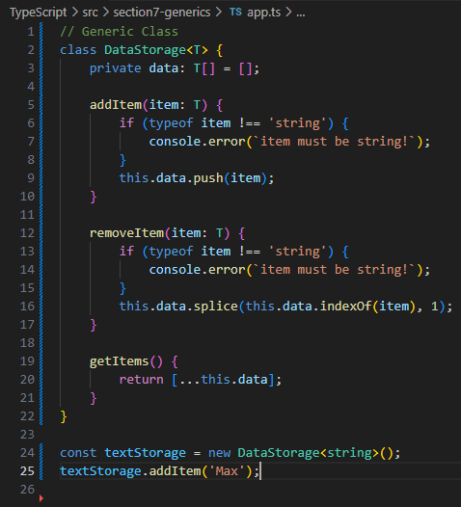

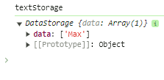

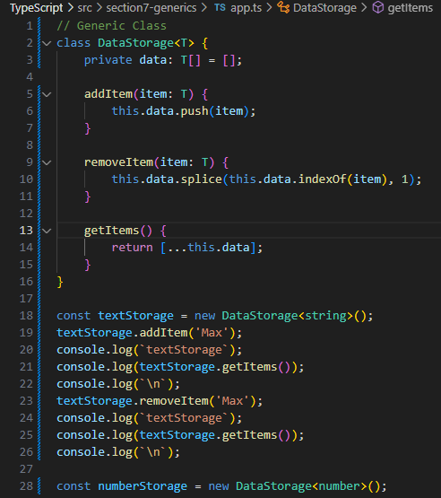

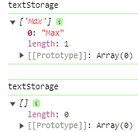

// removing object {name: 'Manu'}

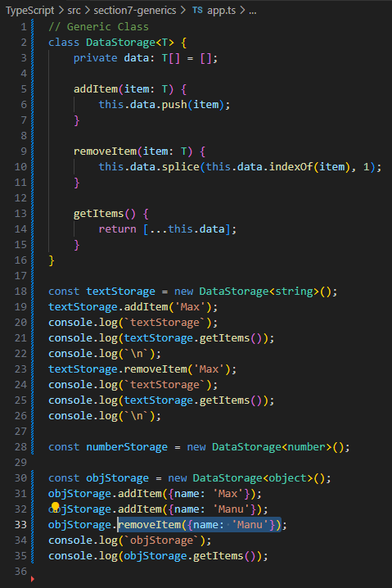

// this seems fine but...

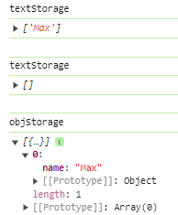

// if removing obj {name: 'Max'}

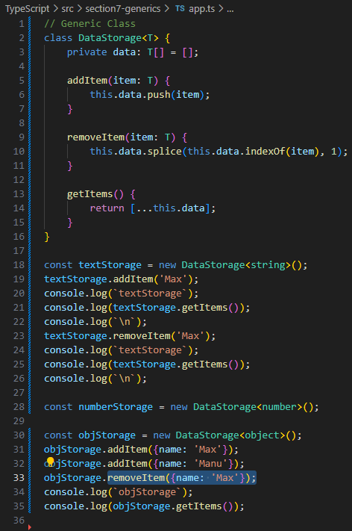

// object {name: 'Max'} is still there...

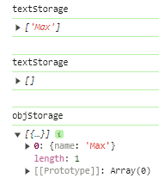

// Workaround is to **confirm** removeItem(item: T) has an **index check**

// of parsed Object

// original **removeItem(item: T)** will **always removes** the **last element** in an **array**, this is due to **JavaScript behaviour**

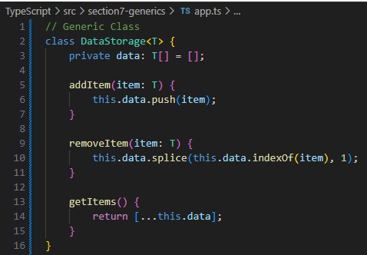

// this **indexOf(item) === -1 guard** will **break** the method of how **JavaScript always remove** the **last element** by **returning nothing**

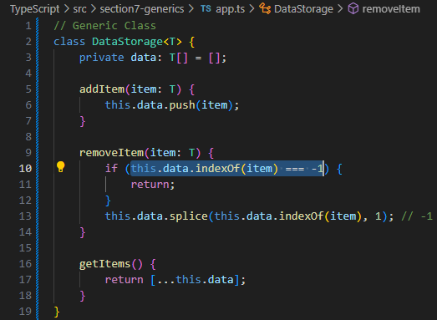

// objStorage.**addItem({name: 'Max')};**

// objStorage.**addItem({name: 'Max')};**

// this **will add 2 objects sharing same key** - name: 'Max' to textStorage object, **each object** {name: 'Max'} **looks** the **same but each object** will **have a unique Memory Address**

// hard to manage object operations

// **const maxObj = {name: 'Max'};**

// this will create a unique object to be stored in textStorage object by assigning a **unique Memory Address**

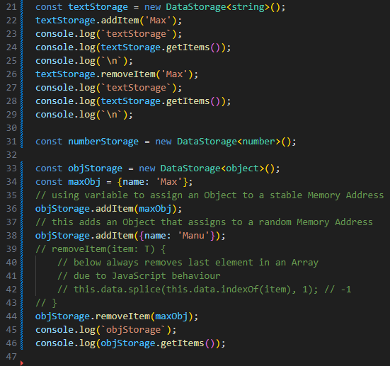

// now {name: 'Max'} can be successfully removed by addressing its unique Memory Address

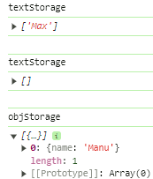

Utility Types

Friday, April 12, 2024

5:45 PM

<https://www.typescriptlang.org/docs/handbook/utility-types.html>

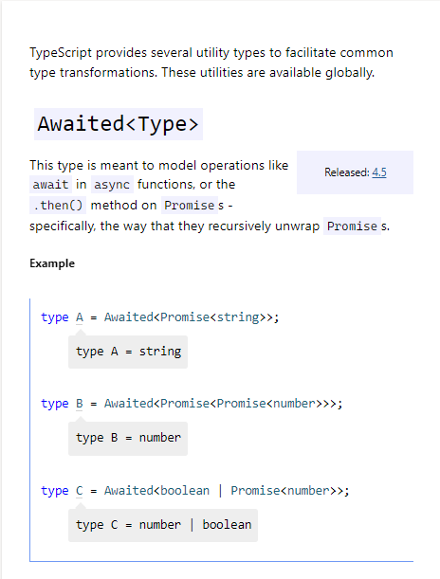

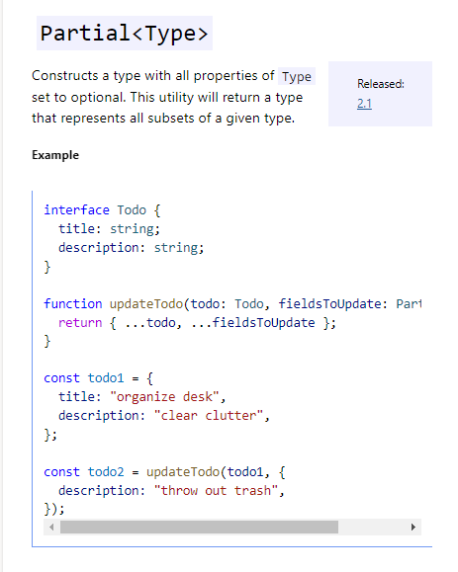

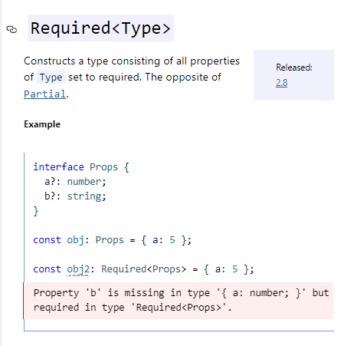

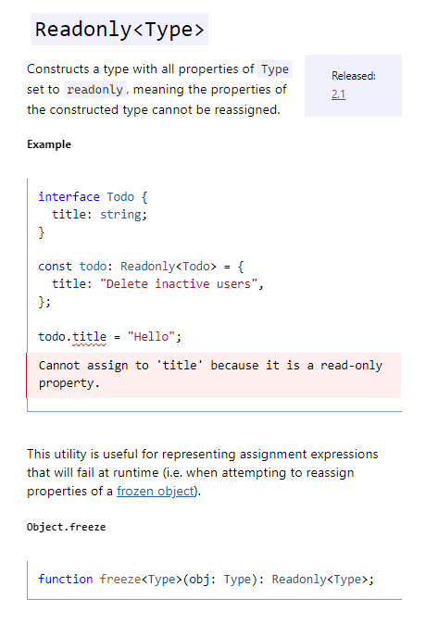

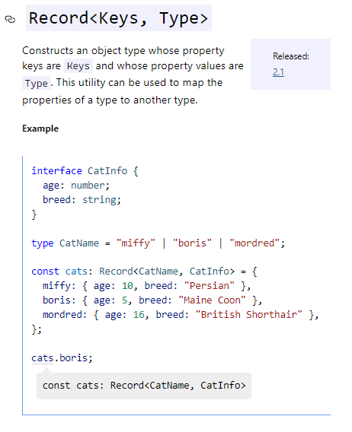

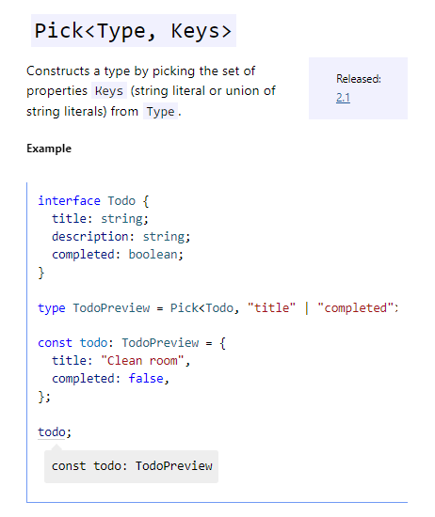

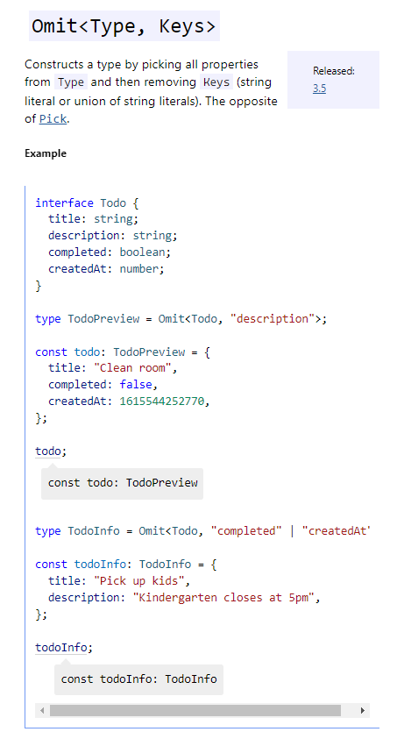

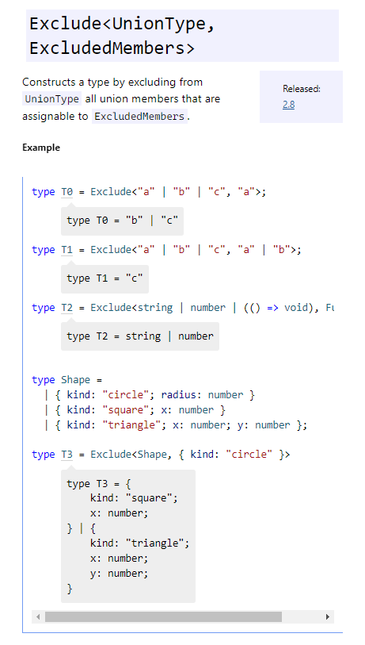

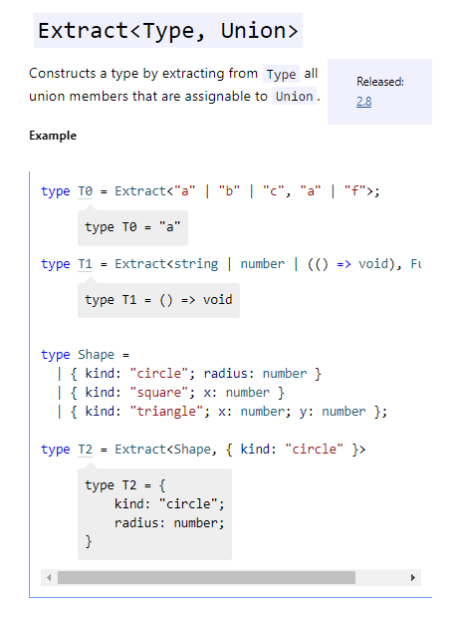

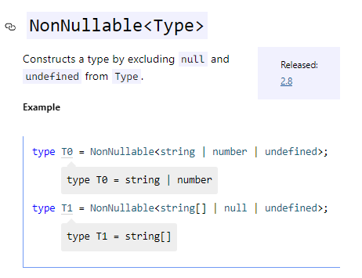

Generic Utility Types

Saturday, April 13, 2024

10:03 AM

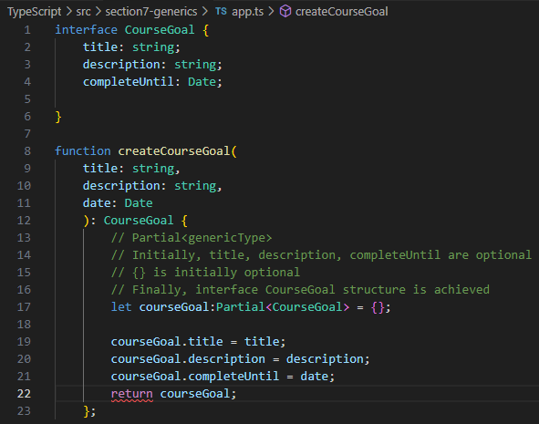

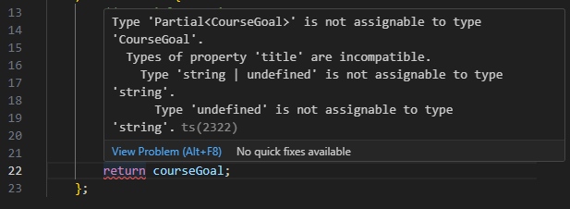

// use Type Casting to fix this type 'undefined' is not assignable to type 'string' issue

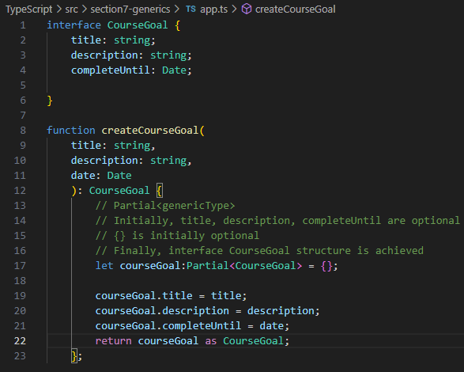

// Readonly type + Generic Type

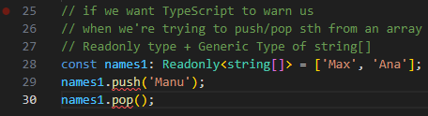

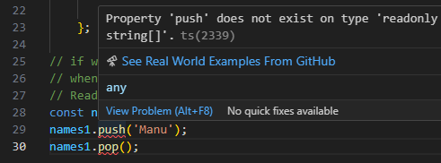

// **Partial<genericType> to open things up**

// **Readonly<genericType> to lock things up**

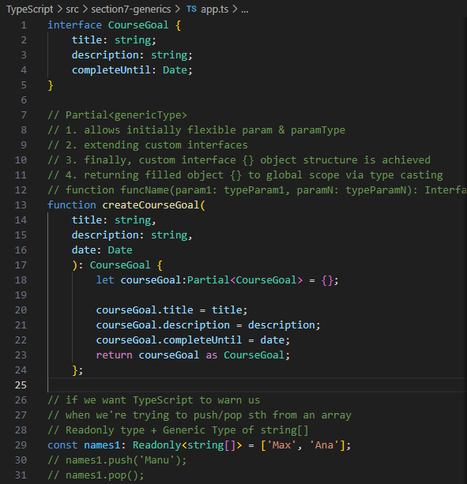

Generic Type vs Union Type

Saturday, April 13, 2024

8:24 PM

1

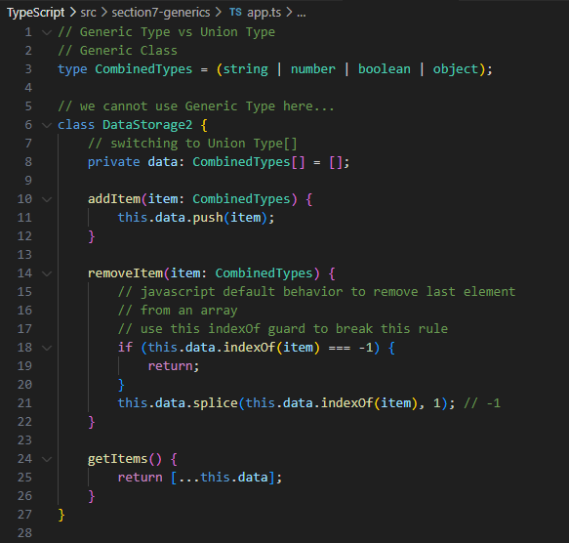

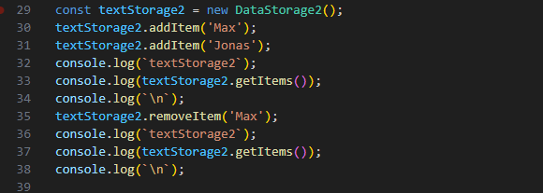

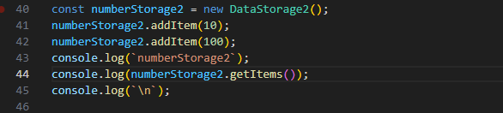

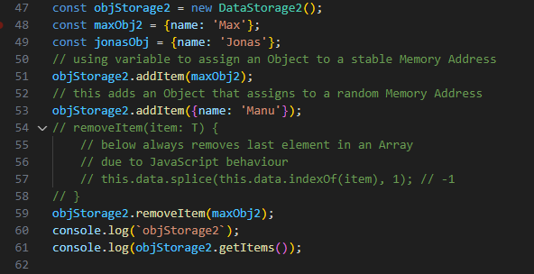

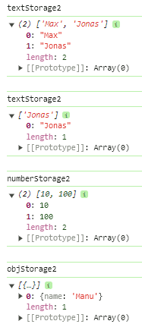

more exercises

Saturday, April 13, 2024

9:06 PM

// perfect case of Generics = flexible parsed arguments

// precise type mapping at the end ;)

// using custom Union Types can precisely address flexible types of parsed arrays

// Approach 1 => Union Types

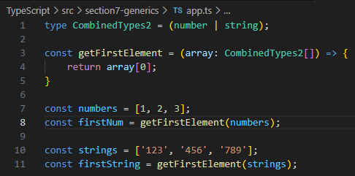

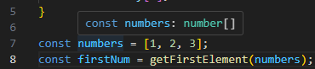

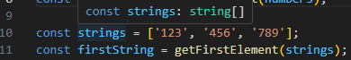

// Approach 2 => Generic Types

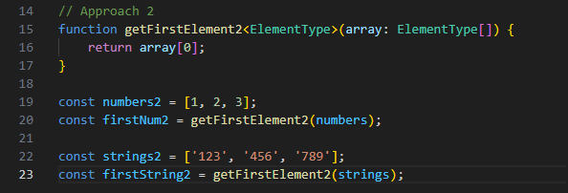

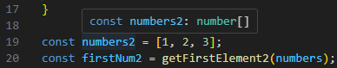

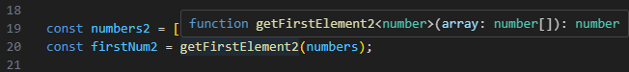

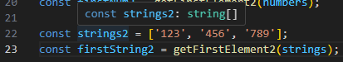

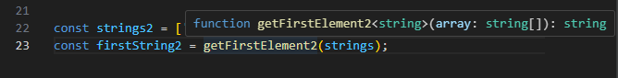

// using more Complicated yet Flexible Generic Functions

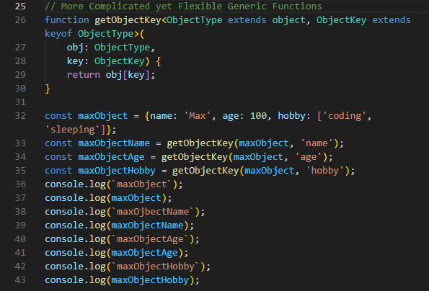

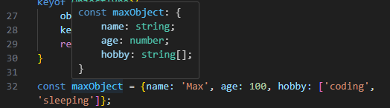

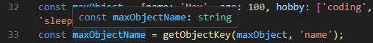

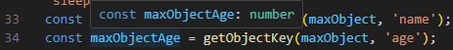

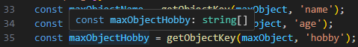

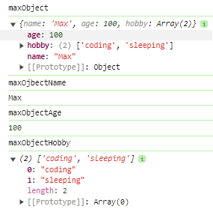

useful resources

Saturday, April 13, 2024

8:38 PM

<https://www.typescriptlang.org/docs/handbook/generics.html>